**DATA MINING LAB PRACTICAL**

(**Semester- V** of B.Tech)



**LAB MANUAL**

**Submitted to:**

Prof. Anand Gupta

**Submitted by:**

2020UCS (CSE – 3)

# **LIST OF EXPERIMENTS**

| S.No. | **NAME OF THE EXPERIMENT** |
| --- | --- |
|  | Create An Employee Table With The Help Of Data Mining Tool Weka |
|  | .a.Build Data Warehouse/Datamart (Using Open-Source Tools And Other Data Warehouse Tools)  b.Identify Source Tables And Populate Sample Data. |
|  | Conversion Of Various Data Files And Training The Dataset For An Application |
|  | Pre-Processes Techniques On Data Set |
|  | 1. Normalize Weather Data Using Knowledge Flow 2. Normalize Employee Data Using Knowledge Flow |
|  | Procedure For Visualization For  A.Weather Table  B.Banking Table |
|  | Implement One Rule (1R ) Algorithm Implement Decision Tree |
|  | Implement Naïve Bayes Classifier Implement Random Forest |
|  | Implement Apriori Technique Implement FP Growth Technique |
|  | Implement K-Means Clustering Algorithm Calculate Information Gain Measure of Features |

Data Mining Lab- (COCSC16)

**Contents**

| **S.No** | **Name of experiments** | **Page No** | **Remarks** |
| --- | --- | --- | --- |
| 1. | Create An Employee Table With The Help Of Data Mining Tool Weka | 4-5 |  |
| 2. | a.Build Data Warehouse/Datamart (Using Open-Source Tools And Other Data Warehouse Tools)  b. Identify Source Tables And Populate Sample Data. | 6-11 |  |
| 3. | Conversion Of Various Data Files And Training The Dataset For An Application | 12-14 |  |
| 4. | Pre-Processes Techniques On Data Set | 15-18 |  |
| 5. | 1. Normalize Weather Data Using Knowledge Flow 2. Normalize Employee Data Using Knowledge Flow | 19-23 |  |
| 6. | Procedure For Visualization For  A.Weather Table   1. Banking Table | 24-29 |  |
| 7. | Implement One Rule (1R ) Algorithm Implement Decision Tree | 30-36 |  |
| 8. | Implement Naïve Bayes Classifier Implement Random Forest | 37-48 |  |
| 9. | Implement Apriori Technique Implement FP Growth Technique | 49-57 |  |
| 10. | Implement K-Means Clustering Algorithm Calculate Information Gain Measure of Features | 58-67 |  |

# **Practical – 1**

## AIM OF EXPERIMENT:

To Create an Employee Table with the help of Data Mining Tool WEKA.

**Description:**

WEKA - an open source software provides tools for data pre-processing, implementation of several Machine Learning algorithms, and visualization tools so that you can develop machine learning techniques and apply them to real-world data mining problems.

The default file type in WEKA is arff.

An **Arff** file contains two sections - header and data.

* The header describes the attribute types.
* The data section contains a comma separated list of data.

We need to create a Weather table with training data set which includes attributes like outlook, temperature, humidity, windy, play.

## Procedure:

1. Open a text editor
2. Type the following training data set with the help of Notepad for Weather Table. @relation weather

@attribute outlook {sunny,rainy,overcast} @attribute temparature numeric @attribute humidity numeric

@attribute windy {true,false} @attribute play {yes,no}

@data sunny,85.0,85.0,false,no overcast,80.0,90.0,true,no sunny,83.0,86.0,false,yes rainy,70.0,86.0,false,yes rainy,68.0,80.0,false,yes rainy,65.0,70.0,true,no overcast,64.0,65.0,false,yes sunny,72.0,95.0,true,no sunny,69.0,70.0,false,yes rainy,75.0,80.0,false,yes

1. After that the file is saved with .arff file format
2. The file is saved in arff format. Now open the weka application.
3. Click on weka-3-4, then Weka dialog box is displayed on the screen.
4. In that dialog box there are four modes, click on explorer.
5. Explorer shows many options. In that click on ‘open file’ and select the arff file
6. Click on edit button which shows weather table on weka.

## Result:

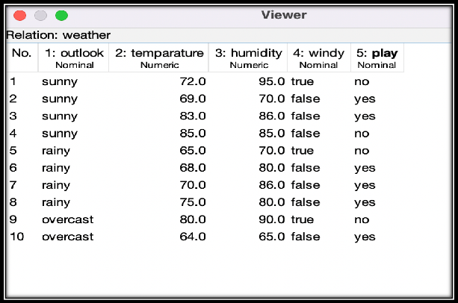

The Datafile was successfully created and loaded into the WEKA explorer.

**Conclusion:**

Successful procedure to load arff dataset in WEKA was followed.

**Practical – 2**

**Aim of Experiment:**

* 1. Build Data Warehouse/Data Mart (using open source tools like Pentaho Data Integration Tool, Pentaho Business Analytics; or other data warehouse tools like Microsoft-SSIS,Informatica,Business Objects, etc.,)
  2. Identify source tables and populate sample data.

**Description:**

The data warehouse contains 4 tables:

* + 1. Date dimension: contains every single date from 2006 to 2016.
    2. Customer dimension: contains 100 customers. To be simple we’ll make it type 1 so we

don’t create a new row for each change.

* + 1. Van dimension: contains 20 vans. To be simple we’ll make it type 1 so we don’t create a

new row for each change.

* + 1. Hire fact table: contains 1000 hire transactions since 1st Jan 2011. It is a daily snapshot fact table so that every day we insert 1000 rows into this fact table. So over time we can track

the changes of total bill, van charges, satnav income, etc.

**Procedure:**

1. So now we are going to create the 3 tables in HireBase database: Customer, Van, and Hire. Then we populate them.

Following script is used to create and populate the source tables:

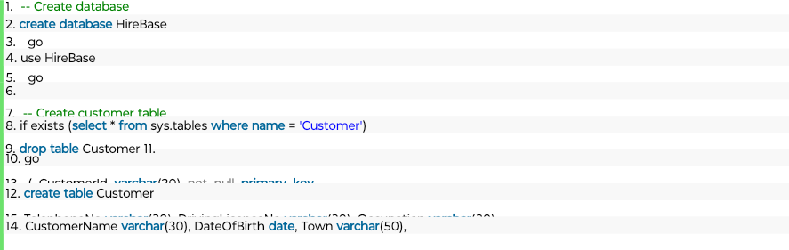

16. )

17. go 18.

1. -- Populate Customer
2. **truncate table** Customer
3. go 22.
4. **declare** @i **int**, @si **varchar**(10), @startdate **date**
5. **set** @i = 1
6. while @i <= 100
7. **begin**
8. **set** @si = right('0'+CONVERT(**varchar**(10), @i),2)
9. **insert into** Customer
10. ( CustomerId, CustomerName, DateOfBirth, Town, TelephoneNo, DrivingLicenceNo, Occupation)
11. **values**

31. ( 'N'+@si, 'Customer'+@si, DATEADD(d,@i-1,'2000-01-01'), 'Town'+@si, 'Phone'+@si, 'Licence'+@si, 'Occupation'+@si)

1. **set** @i = @i + 1
2. **end**
3. go 35.

36. **select** * **from** Customer 37.

1. -- Create Van table
2. if exists (**select** * **from** sys.tables **where name** = 'Van')
3. **drop table** Van
4. go 42.
5. **create table** Van
6. ( RegNo **varchar**(10) not null **primary key**,
7. Make **varchar**(30), Model **varchar**(30), [Year] **varchar**(4),
8. Colour **varchar**(20), CC **int**, Class **varchar**(10)

47. )

48. go 49.

1. -- Populate Van table
2. **truncate table** Van
3. go 53.
4. **declare** @i **int**, @si **varchar**(10)
5. **set** @i = 1
6. while @i <= 20
7. **begin**
8. **set** @si = convert(**varchar**, @i)
9. **insert into** Van
10. ( RegNo, Make, Model, [Year], Colour, CC, Class)
11. **values**
12. ( 'Reg'+@si, 'Make'+@si, 'Model'+@si,
13. case @i%4 **when** 0 **then** 2008 **when** 1 **then** 2009 **when** 2 **then** 2010 **when** 3 **then** 2011 **end**,
14. case **when** @i%5<3 **then** 'White' **else** 'Black' **end**,
15. case @i%3 **when** 0 **then** 2000 **when** 1 **then** 2500 **when** 2 **then** 3000 **end**,
16. case @i%3 **when** 0 **then** 'Small' **when** 1 **then** 'Medium' **when** 2 **then** 'Large' **end**)
17. **set** @i = @i + 1
18. **end**
19. go 70.

71. **select** * **from** Van 72.

1. -- Create Hire table
2. if exists (**select** * **from** sys.tables **where name** = 'Hire')
3. **drop table** Hire
4. go 77.
5. **create table** Hire
6. ( HireId **varchar**(10) not null **primary key**,
7. HireDate **date** not null,
8. CustomerId **varchar**(20) not null,
9. RegNo **varchar**(10), NoOfDays **int**, VanHire money, SatNavHire money,
10. Insurance money, DamageWaiver money, TotalBill money

84. )

85. go 86.

87. -- Populate Hire table

| 88. **truncate table** Hire |
| --- |
| 89. go |
| 90. |
| 91. **declare** @i **int**, @si **varchar**(10), @DaysFrom1stJan **int**, @CustomerId **int**, @RegNo **int**, @mi **int** |
| 92. **set** @i = 1 |
| 93. while @i <= 1000 |
| 94. **begin** |
| 95. **set** @si = right('000'+convert(**varchar**(10), @i),4) -- string of i |
| 96. **set** @DaysFrom1stJan = (@i-1)%200 --The Hire Date is derived from i modulo 200 |
| 97. **set** @CustomerId = (@i-1)%100+1 --The CustomerId is derived from i modulo 100 |
| 98. **set** @RegNo = (@i-1)%20+1 --The Van RegNo is derived from i modulo 20 |
| 99. **set** @mi = (@i-1)%3+1 --i modulo 3 |
| 100. **insert into** Hire (HireId, HireDate, CustomerId, RegNo, NoOfDays, VanHire, SatNavHire, Insurance,  DamageWaiver, TotalBill) |
| 101. **values** ('H'+@si, DateAdd(d, @DaysFrom1stJan, '2011-01-01'), |
| 102. left('N0'+CONVERT(**varchar**(10),@CustomerId),3), 'Reg'+CONVERT(**varchar**(10), @RegNo), |
| 103. @mi, @mi*100, @mi*10, @mi*20, @mi*40, @mi*170) |
| 104. **set** @i += 1 |
| 105.**end** |
| 106.go |
| 107. |
| 108. **select** * **from** Hire  109. |

## Result:

The Final Outcome is as follow :

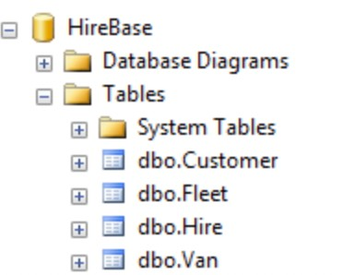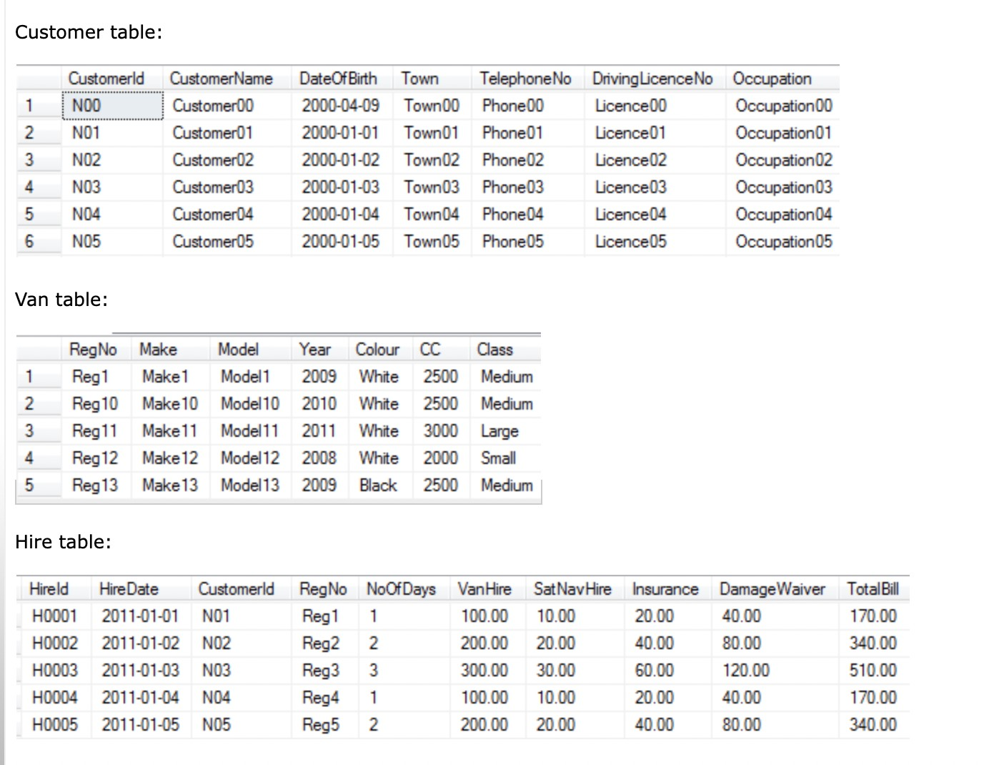

2. Create Data WareHouse

So now we are going to create the 3 dimension tables and 1 fact table in the data warehouse: DimDate, DimCustomer, DimVan and FactHire. We are going to populate the 3 dimensions but we’ll leave the fact table empty. The purpose of this article is to show how to populate the fact table using SSIS.

1. --Create the data warehouse
2. create database TopHireDW
3. go
4. use TopHireDW
5. go 6.
6. -- Create Date Dimension
7. if exists (select * from sys.tables where name = 'DimDate')
8. drop table DimDate
9. go 11.
10. create table DimDate
11. ( DateKey int not null primary key,
12. [Year] varchar(7), [Month] varchar(7), [Date] date, DateString varchar(10))
13. go 16.
14. -- Populate Date Dimension
15. truncate table DimDate
16. go 20.
17. declare @i int, @Date date, @StartDate date, @EndDate date, @DateKey int,
18. @DateString varchar(10), @Year varchar(4),
19. @Month varchar(7), @Date1 varchar(20) 24. set @StartDate = '2006-01-01'

25. set @EndDate = '2016-12-31'

26. set @Date = @StartDate 27.

1. insert into DimDate (DateKey, [Year], [Month], [Date], DateString)
2. values (0, 'Unknown', 'Unknown', '0001-01-01', 'Unknown') --The unknown row 30.
3. while @Date <= @EndDate
4. begin
5. set @DateString = convert(varchar(10), @Date, 20)
6. set @DateKey = convert(int, replace(@DateString,'-',''))
7. set @Year = left(@DateString,4)
8. set @Month = left(@DateString, 7)
9. insert into DimDate (DateKey, [Year], [Month], [Date], DateString)
10. values (@DateKey, @Year, @Month, @Date, @DateString)
11. set @Date = dateadd(d, 1, @Date)
12. end
13. go 42.

43. select * from DimDate 44.

1. -- Create Customer dimension
2. if exists (select * from sys.tables where name = 'DimCustomer')
3. drop table DimCustomer
4. go 49.
5. create table DimCustomer
6. ( CustomerKey int not null identity(1,1) primary key,
7. CustomerId varchar(20) not null,
8. CustomerName varchar(30), DateOfBirth date, Town varchar(50),
9. TelephoneNo varchar(30), DrivingLicenceNo varchar(30), Occupation varchar(30)

55. )

56. go 57.

1. insert into DimCustomer (CustomerId, CustomerName, DateOfBirth, Town, TelephoneNo,
2. DrivingLicenceNo, Occupation)
3. select * from HireBase.dbo.Customer 61.
4. select * from DimCustomer 63.

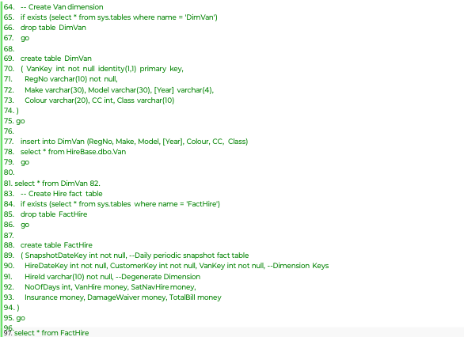

Result :

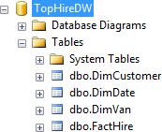

Date Dimension:

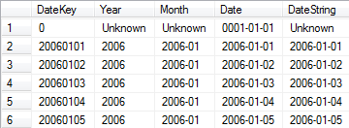

Customer Dimension:

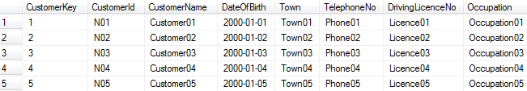

Van Dimension:

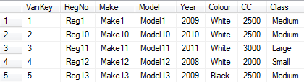

Hire Fact Table:

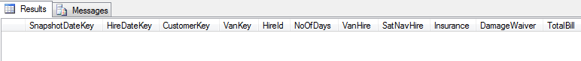

## Conclusion:

We Build a data warehouse and populated the source tables with sample data.

**Practical – 3**

**Aim Of Experiment:**

* 1. Conversion of various Datafile.
  2. Training the dataset for an application and applying test options to it.

## Description:

Dataset files can be of many different formats. We sometimes may require to convert the dataset file to a particular format as per need. WEKA provide support for many file formats. The arff file format is the default file format to work in WEKA.

The file formats supported by WEKA are:

Arff arff.gz bsi csv dat data Json json.gz libsvm m names xrff

Arff, JSON, CSV are the widely used file format in dataset.

WEKA provide support of many in-built machine learning algorithms. The machine learning algorithms can be used to perform classification, clustering and regression analysis. The machine learning algorithms can be trained using the dataset and can be checked for metrics against the test options provided in WEKA.

#### Test Options

The result of applying the chosen classifier will be tested according to the options that are set by clicking in the Test options box.

There are four test modes:

1. **Use training set.** The classifier is evaluated on how well it predicts the class of the instances it was trained on.
2. **Supplied test set.** The classifier is evaluated on how well it predicts the class of a set of instances loaded from a file. Clicking the Set... button brings up a dialog allowing you to choose the file to test on.
3. **Cross-validation.** The classifier is evaluated by cross-validation, using the number of folds that are entered in the Folds text field.
4. **Percentage split.** The classifier is evaluated on how well it predicts a certain percentage of the data which is held out for testing. The amount of data held out depends on the value entered in the % field.

Unless you have your own training set or a client supplied test set, you would use cross- validation or percentage split options. Under cross-validation, you can set the number of folds in which entire data would be split and used during each iteration of training. In the percentage split, you will split the data between training and testing using the set split percentage.

## Procedure:

#### Conversion of Datafile Formats

1. Open WEKA
2. Open WEKA explorer.
3. Click on the open file button and load the datafile in any of the supported format.
4. Click on the Save button and select the file format we want for the datafile.
5. Confirm by naming the file , choosing the file format and click on save

The Data File is saved in that file format.

This can be used to convert the datafile in/from various file format supported by Weka.

#### Training the dataset for an application

We will use the weather data to train a classifier to predict if play is possible or not .

1. Open WEKA. Go to Explorer.
2. Load the dataset into the explorer using open file button.
3. We will use the nominal weather dataset to predict if play /not play, using naïve bayes classifier.
4. We see the result of applying the classifier by choosing one of the test options and looking at the metrics in classifier output window.

## RESULT:

#### Conversion of file format:

We were able to convert the arff file to Csv and vice versa.

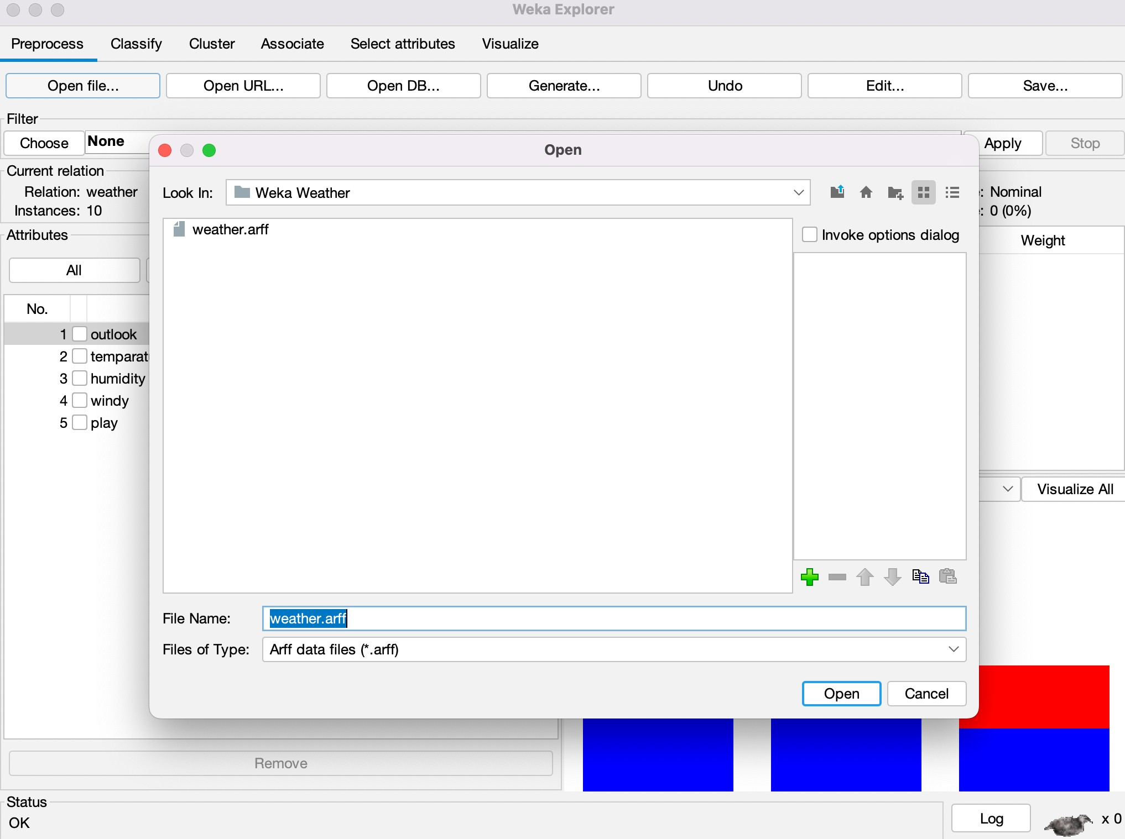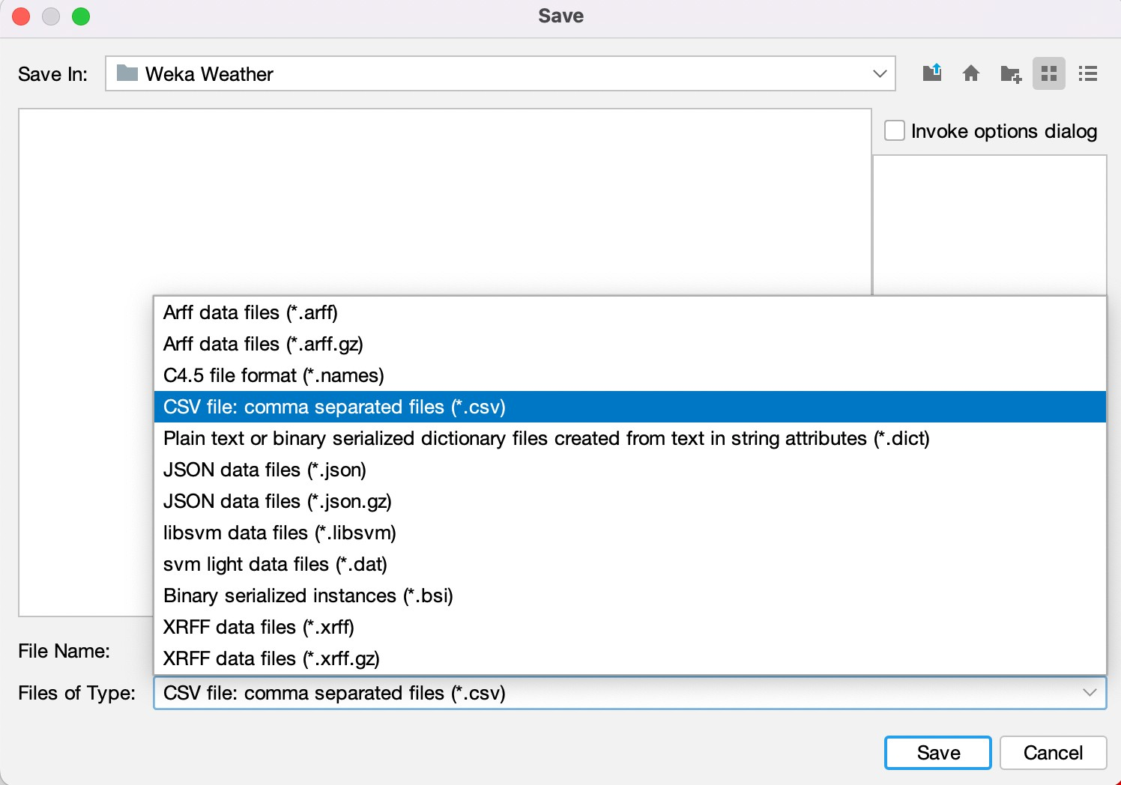

#### Training the Dataset

We trained the dataset to classify the play attribute.

Test mode:evaluate on training data. Test mode:10-fold cross-validation

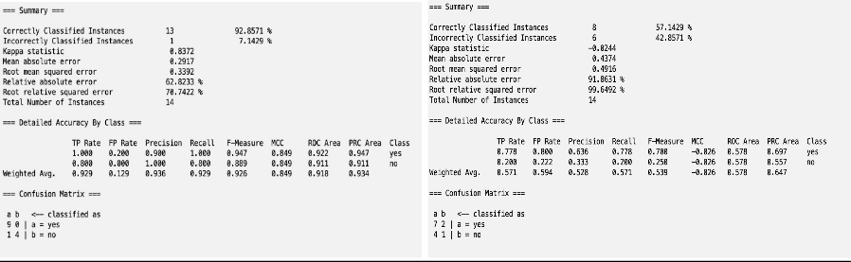

Test mode:5-fold cross-validation Test mode:split 66.0% train, remainder test

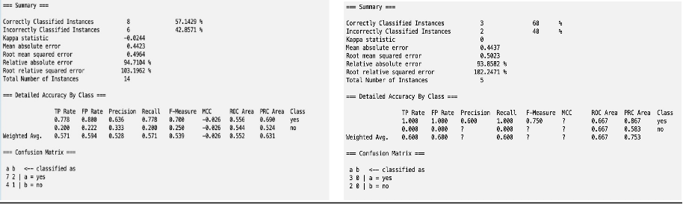

## Conclusion:

We converted arff to CSV file .

We trained a naïve bayes classification model in the weather dataset and tested the model with various test options. The best was against the training data.

**Practical – 4**

**Aim of Experiment:**

To apply pre-processing techniques on the dataset.

## Description:

Real world databases are highly influenced to noise, missing and inconsistency due to their queue size so the data can be pre-processed to improve the quality of data and missing results and it also improves the efficiency. For example, the data may contain null fields, it may contain columns that are irrelevant to the current analysis, and so on. Thus, the data must be pre-processed to meet the requirements of the type of analysis you are seeking. This is the done in the pre-processing module.

There are 3 pre-processing techniques they are:

* 1. Add
  2. Remove
  3. Normalization

## Procedure:

#### Load the dataset into WEKA :

1. Open WEKA.
2. Click on the ‘Open File’ button.
3. Navigate to Weka Data Folder containing sample datasets.
4. Choose the Weather Dataset and click Open.

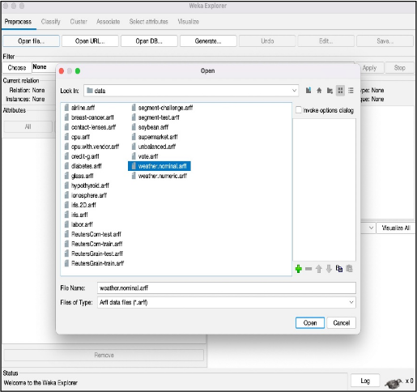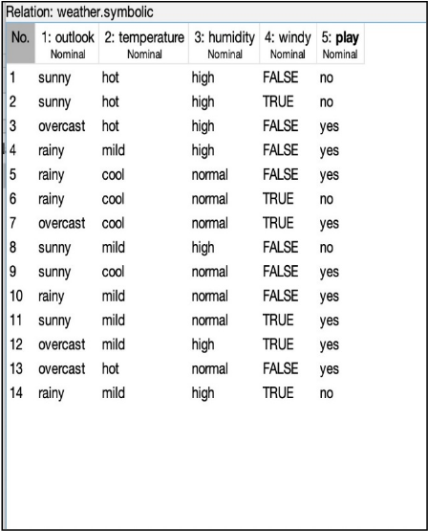

## Adding Attribute :

1. After loading the Dataset into Explorer.
2. Under the Filter Tab. Click on the choose button and select filter option.
3. In Filters, we have Supervised and Unsupervised data.
4. Click on Unsupervised data.
5. Select the Attribute add. A new window is opened.
6. In that we add attribute index, type, data format, nominal label values for Climate. Click on OK.
7. Click on the Apply button.
8. A new Attribute is added to Weather Table.
9. Save the File and preview the new Data File.

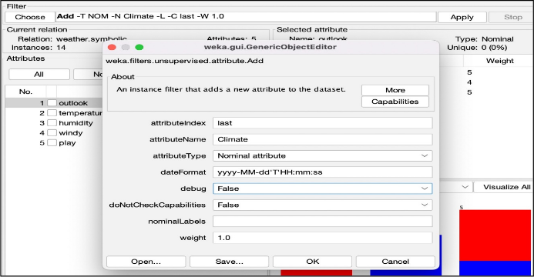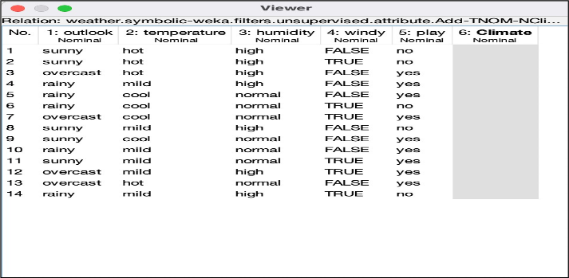

#### Removing Attribute :

1. After Loading the dataset into WEKA explorer.
2. Under the Filter Tab. Click on the choose button and select filter option.
3. In Filters, we have Supervised and Unsupervised data.
4. Click on Unsupervised data.
5. Select the Attribute Remove.
6. Select the attributes to Remove.(windy in our case)
7. Click the Remove Button.
8. Apply the changes. The Weather Dataset is changed it can be Viewed in Edit.

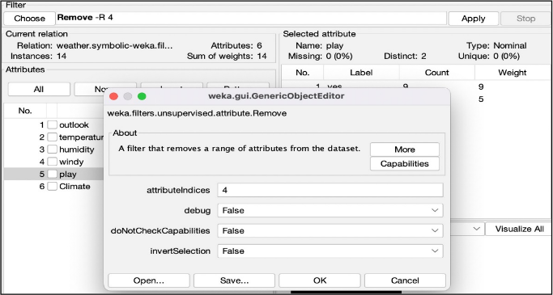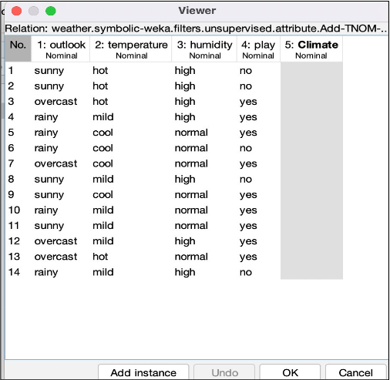

#### Normalizing an attribute :

1. After Loading the dataset into WEKA explorer.
2. Under the Filter Tab. Click on the choose button and select filter option.
3. In Filters, we have Supervised and Unsupervised data.
4. Click on Unsupervised data.
5. Select the Attribute Normalize.
6. The numeric attributes are normalized.(temperature, humidity in our case)
7. Click the OK Button and continue.
8. Apply the changes. The Weather Dataset is Normalized it can be Viewed in Edit.

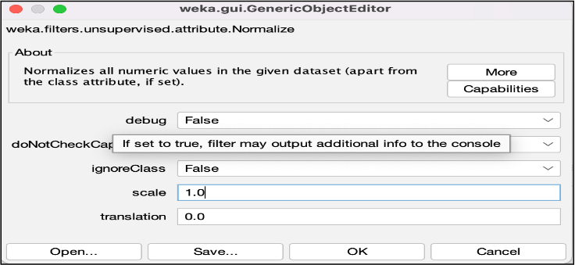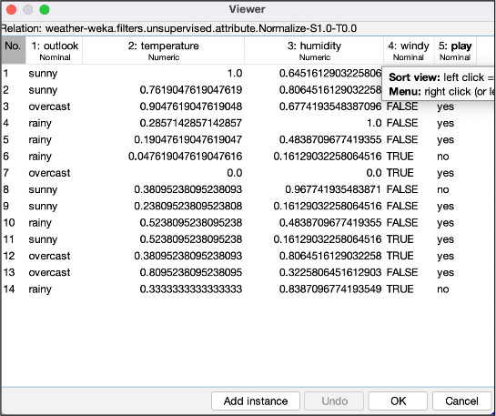

## Conclusion :

We performed pre-processing techniques on the Weather dataset including adding attribute, removing attribute and normalizing attribute.

# **Practical – 5**

## Aim of Experiment :

Perform Normalization of Dataset using Knowledge Flow in WEKA.

**Description :**

The knowledge flow provides an alternative way to the explorer as a graphical front end to WEKA’s algorithm.

The Knowledge Flow presents a data-flow inspired interface to WEKA. The user can select WEKA components from a palette, place them on a layout canvas and connect them together in order to form a knowledge flow for processing and analysing data.

At present, all of WEKA’s classifiers, filters, clusterers, associators, loaders and savers are available in the Knowledge Flow along with some extra tools.

Knowledge flow presents a dataflow interface to WEKA. The user can select WEKA components from a toolbar placed them on a layout campus and connect them together in order to form a knowledge flow for processing and analysing the data.

## Procedure :

#### Using Weather Dataset

**Open and View the Weather Dataset**

* + 1. Open WEKA.
    2. Load the numeric weather dataset into explorer.
    3. Click on Edit button to view the dataset in viewer.

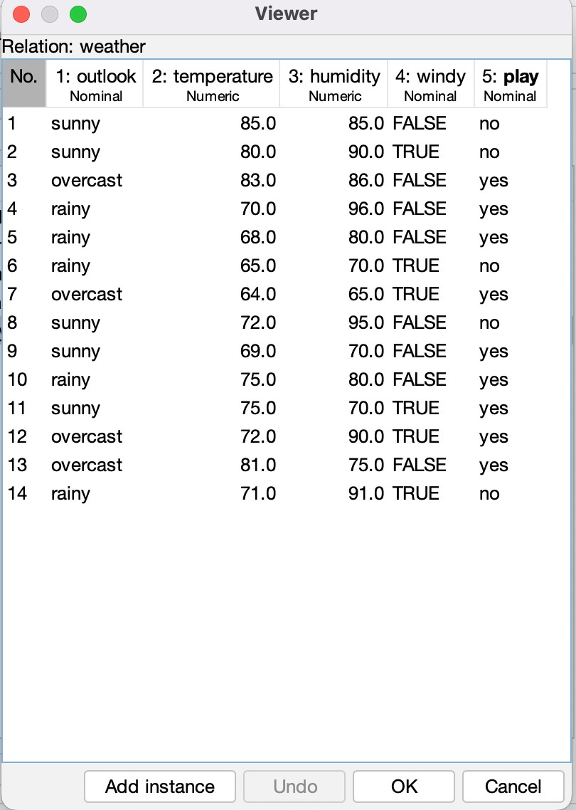

#### Knowledge Flow Procedure :

1. Open the WEKA Application.
2. Open the Knowledge Flow Window.
3. Select the Data Source component and add Arff Loader into the knowledge layout canvas.
4. Select the Filters component and add Attribute Selection and Normalize into the knowledge layout canvas
5. Select the Data Sinks component and add Arff Saver into the knowledge layout canvas.
6. Right click on Arff Loader and select Configure option then the new window will be opened and select Weather.arff
7. Right click on Arff Loader and select Dataset option then establish a link between Arff Loader and Attribute Selection.
8. Right click on Attribute Selection and select Dataset option then establish a link between Attribute Selection and Normalize
9. Right click on Attribute Selection and select Configure option and choose the best attribute for Weather data.
10. Right click on Normalize and select Dataset option then establish a link between Normalize and Arff Saver.
11. Right click on Arff Saver and select Configure option then new window will be opened and set the path, enter .arff in look in dialog box to save normalize data.
12. Right click on Arff Loader and click on Start Loading option then everything will be executed one by one.
13. Check whether output is created or not by selecting the preferred path. 14.Rename the data name as a.arff

15.Double click on a.arff then automatically the output will be opened in MS-Excel.

#### Result :

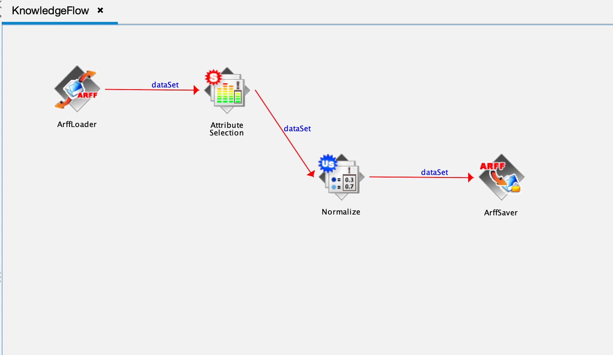

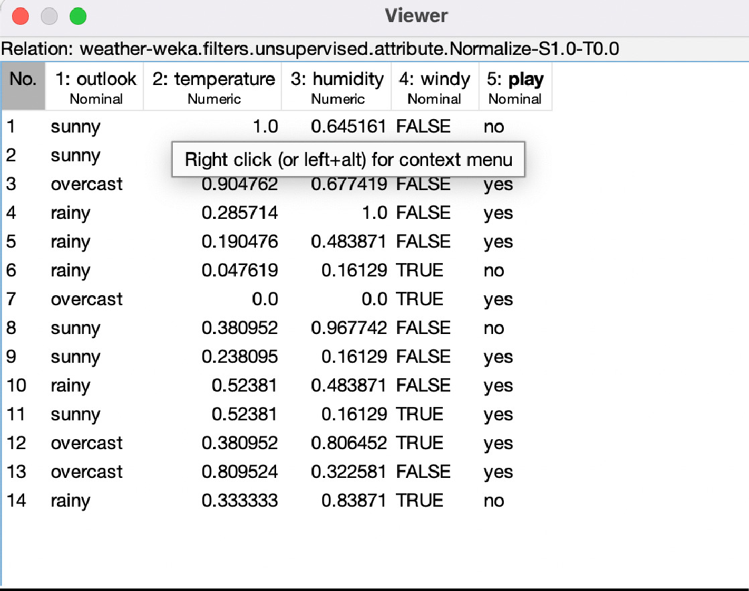

* 1. **Using Employee Dataset**

**Create the Employee Table:**

1. Open a text editor
2. Type the following training data set with the help of Notepad for Weather Table.

@relation employee

@attribute eid numeric @attribute ename

{raj,ramu,anil,sunil,rajiv,sunitha,kavitha,suresh,ravi,ramana,ram,kavya,navya} @attribute salary numeric

@attribute exp numeric

@attribute address {pdtr,kdp,nlr,gtr}

@data 101,raj,10000,4,pdtr 102,ramu,15000,5,pdtr 103,anil,12000,3,kdp 104,sunil,13000,3,kdp 105,rajiv,16000,6,kdp 106,sunitha,15000,5,nlr 107,kavitha,12000,3,nlr 108,suresh,11000,5,gtr 109,ravi,12000,3,gtr 110,ramana,11000,5,gtr 111,ram,12000,3,kdp 112,kavya,13000,4,kdp 113,navya,14000,5,kdp

1. After that the file is saved with .arff file format
2. The file is saved in arff format. Now open the weka application. 13.Click on weka-3-4, then Weka dialog box is displayed on the screen. 14.In that dialog box there are four modes, click on explorer.

15.Explorer shows many options. In that click on ‘open file’ and select the arff file 16.Click on edit button which shows weather table on weka.

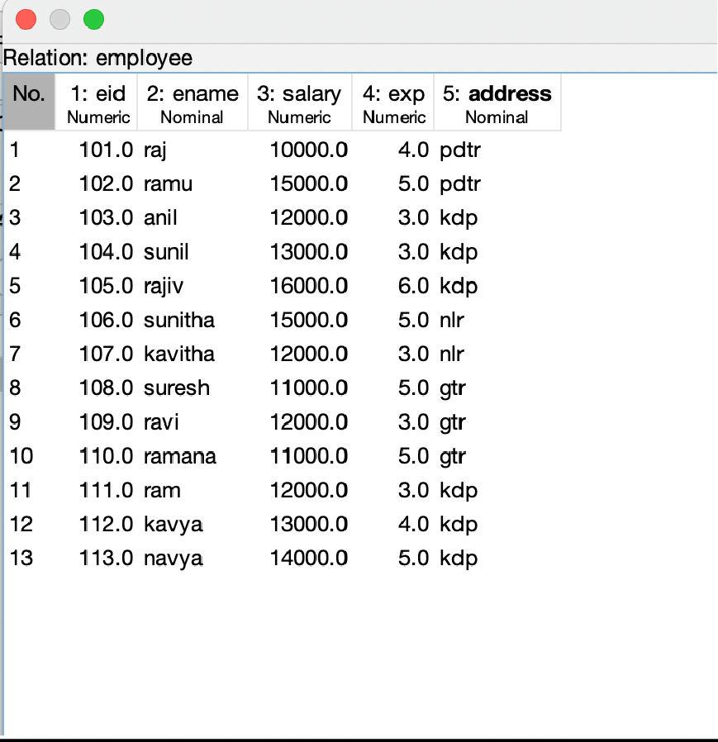

#### Knowledge Flow Procedure :

1. Open the WEKA Application.
2. Open the Knowledge Flow Window.
3. Select the Data Source component and add Arff Loader into the knowledge layout canvas.
4. Select the Filters component and add Attribute Selection and Normalize into the knowledge layout canvas
5. Select the Data Sinks component and add Arff Saver into the knowledge layout canvas.
6. Right click on Arff Loader and select Configure option then the new window will be opened and select Employee.arff
7. Right click on Arff Loader and select Dataset option then establish a link between Arff Loader and Attribute Selection.
8. Right click on Attribute Selection and select Dataset option then establish a link between Attribute Selection and Normalize
9. Right click on Attribute Selection and select Configure option and choose the best attribute for Employee data.
10. Right click on Normalize and select Dataset option then establish a link between Normalize and Arff Saver.
11. Right click on Arff Saver and select Configure option then new window will be opened and set the path, enter .arff in look in dialog box to save normalize data.
12. Right click on Arff Loader and click on Start Loading option then everything will be executed one by one.
13. Check whether output is created or not by selecting the preferred path. 14.Rename the data name as a.arff

15.Double click on a.arff then automatically the output will be opened in MS-Excel.

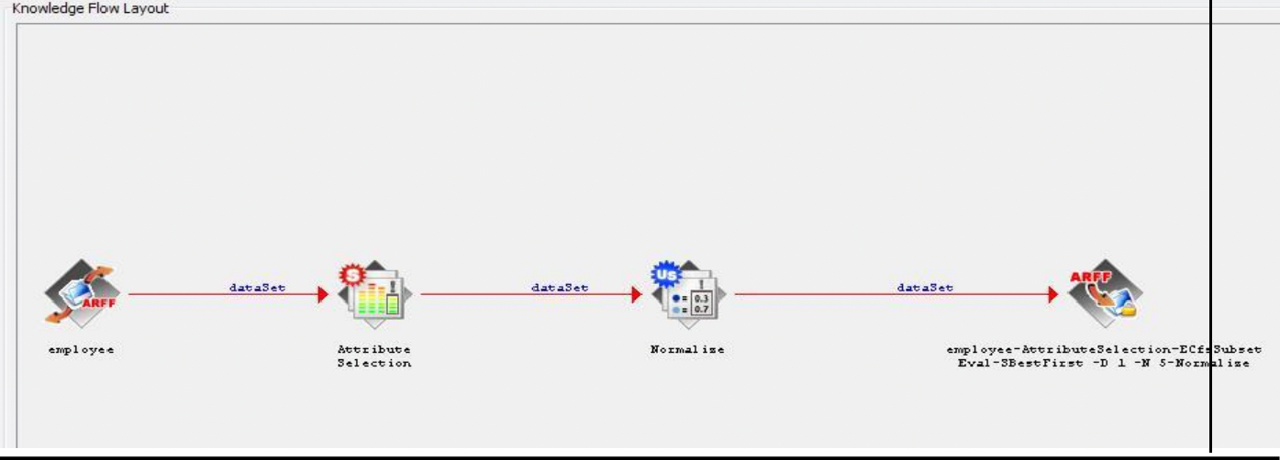

#### Conclusion :

We performed the normalisation of data using knowledge floe interface .

# **Practical – 6**

## Aim Of Experiment :

To Perform Visualization on a.Weather Data.

b. Banking Data.

**Description :**

WEKA’s visualization allows you to visualize a 2-D plot of the current working relation. Visualization is very useful in practice, it helps to determine difficulty of the learning problem. WEKA can visualize single attributes (1-d) and pairs of attributes (2-d), rotate 3-d visualizations (Xgobi-style). WEKA has “Jitter” option to deal with nominal attributes and to detect “hidden” data points.

**Weather Dataset**

1. Open Weka application
2. Load the Weather numeric arff file into the explore window.
3. Click on edit button to view the dataset in viewer.

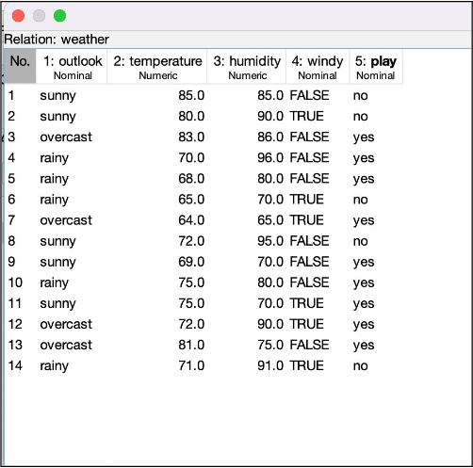

1. Click on the visualise tab on top bar of explorer window.
2. Open the visualise tab then Plot Matrix is displayed on the Screen.
3. After that we select the Select Attribute button, then select Outlook attribute and click OK.
4. Click on the Update button to display the output.
5. After that select the Select Attribute button and select Temperature attribute and then click OK.
6. Increase the Plot Size and Point Size.
7. Click on the Update button to display the output.
8. After that we select the Select Attribute button, then select Humidity attribute and click OK.
9. Click on the Update button to display the output.
10. After that select the Select Attribute button and select Windy attribute and then click OK.
11. Increase the Jitter Size.
12. Click on the Update button to display the output.
13. After that we select the Select Attribute button, then select Play attribute and clock OK.
14. Click on the Update button to display the output.

#### Result :

Plot Matrix

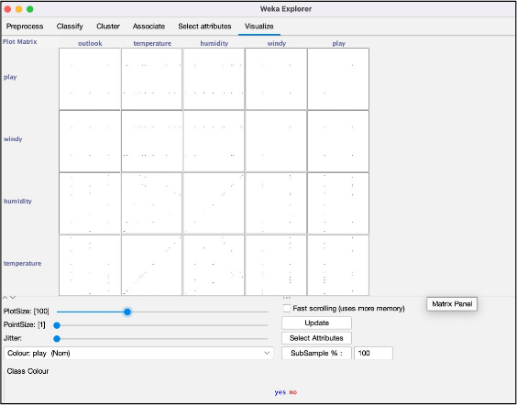

#### Attribute: temperature Attribute: Humidity

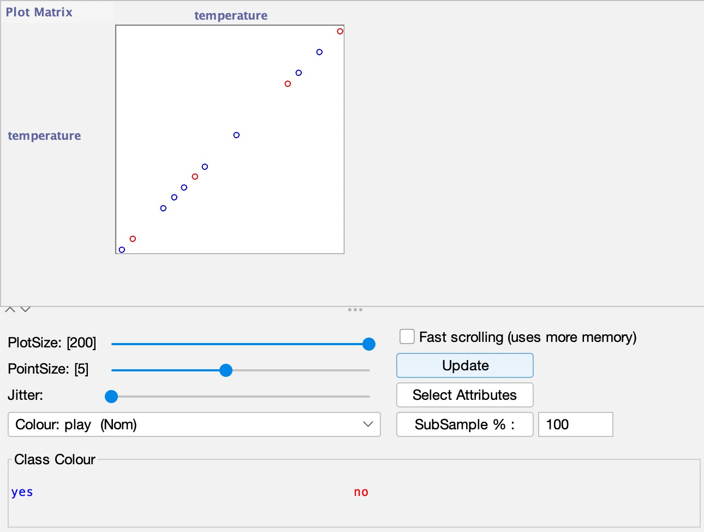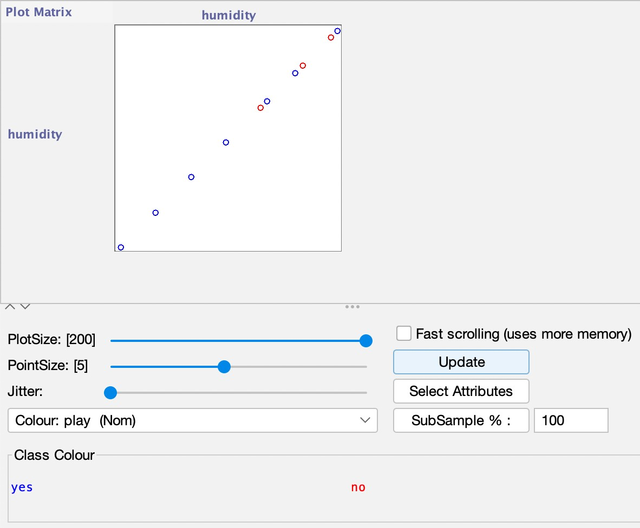

**Attribute: Windy (jitter increased) Attribute: play (jitter)**

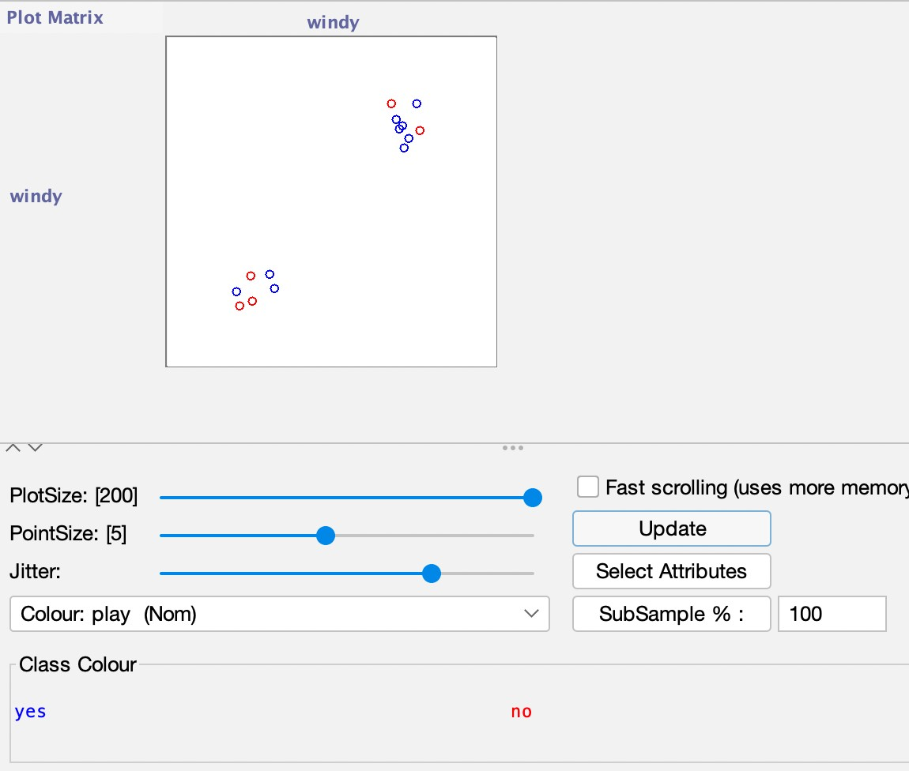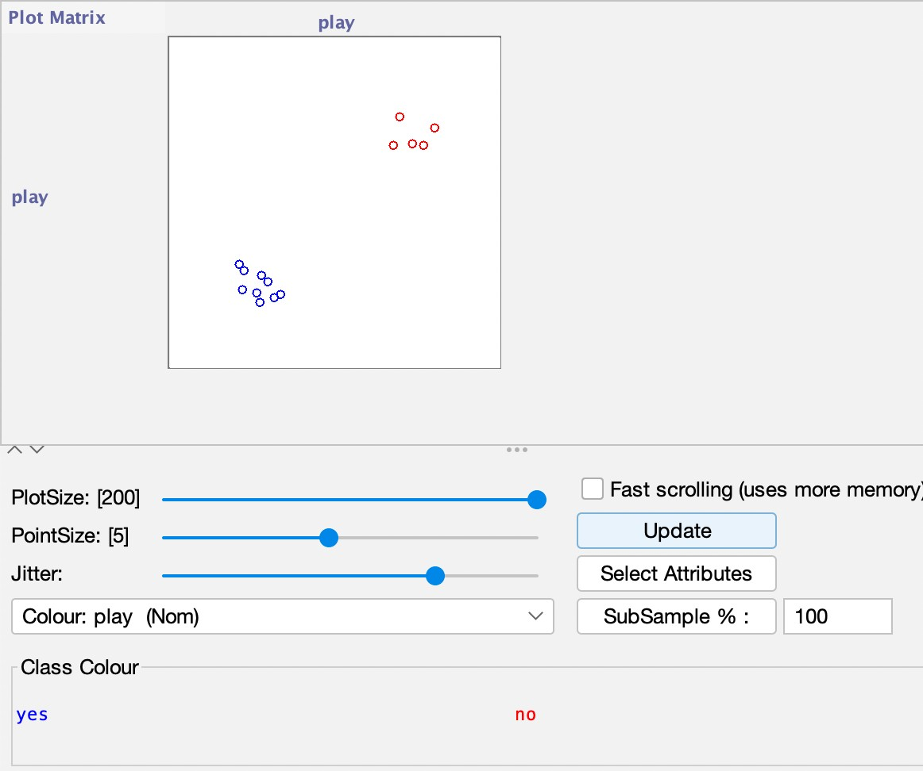

**Banking Dataset**

**Creation of Banking Table:**

1. Open a text editor
2. Type the following training data set with the help of Notepad for Weather Table. @relation bank

@attribute cust {male,female} @attribute

accno{0101,0102,0103,0104,0105,0106,0107,0108,0109,0110,0111,0112,0113

,0114,0115}

@attribute bankname {sbi,hdfc,sbh,ab,rbi} @attribute location {hyd,jmd,antp,pdtr,kdp} @attribute deposit {yes,no}

@data male,0101,sbi,hyd,yes female,0102,hdfc,jmd,no male,0103,sbh,antp,yes male,0104,ab,pdtr,yes female,0105,sbi,jmd,no male,0106,ab,hyd,yes female,0107,rbi,jmd,yes female,0108,hdfc,kdp,no male,0109,sbh,kdp,yes male,0110,ab,jmd,no female,0111,rbi,kdp,yes male,0112,sbi,jmd,yes female,0113,rbi,antp,no male,0114,hdfc,pdtr,yes female,0115,sbh,pdtr,no

1. After that the file is saved with .arff file format
2. The file is saved in arff format. Now open the weka application. 21.Click on weka-3-4, then Weka dialog box is displayed on the screen. 22.In that dialog box there are four modes, click on explorer.

23.Explorer shows many options. In that click on ‘open file’ and select the arff file 24.Click on edit button which shows weather table on weka.

#### Visualisation Procedure:

1. Click on the visualise tab on top bar of explorer window.
2. Open the visualise tab then Plot Matrix is displayed on the Screen.
3. After that we select the Select Attribute button, then select Outlook attribute and click OK.
4. Click on the Update button to display the output.
5. After that select the Select Attribute button and select Temperature attribute and then click OK.
6. Increase the Plot Size and Point Size.
7. Click on the Update button to display the output.
8. After that we select the Select Attribute button, then select Humidity attribute and click OK.
9. Click on the Update button to display the output.
10. After that select the Select Attribute button and select Windy attribute and then click OK.
11. Increase the Jitter Size.
12. Click on the Update button to display the output.
13. After that we select the Select Attribute button, then select Play attribute and clock OK.
14. Click on the Update button to display the output.

#### Result :

**Plot Matrix**

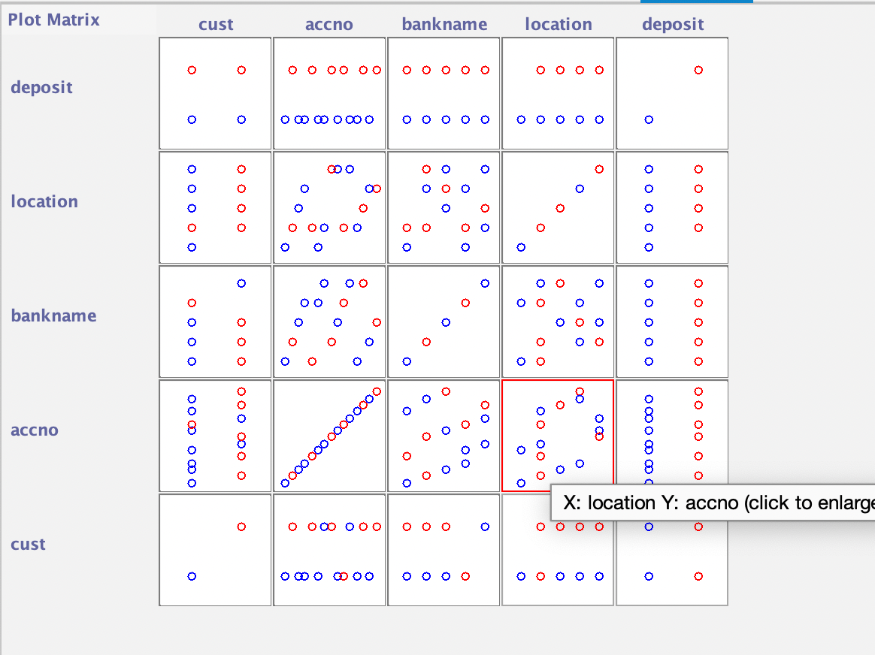

**Attribute : Cust**

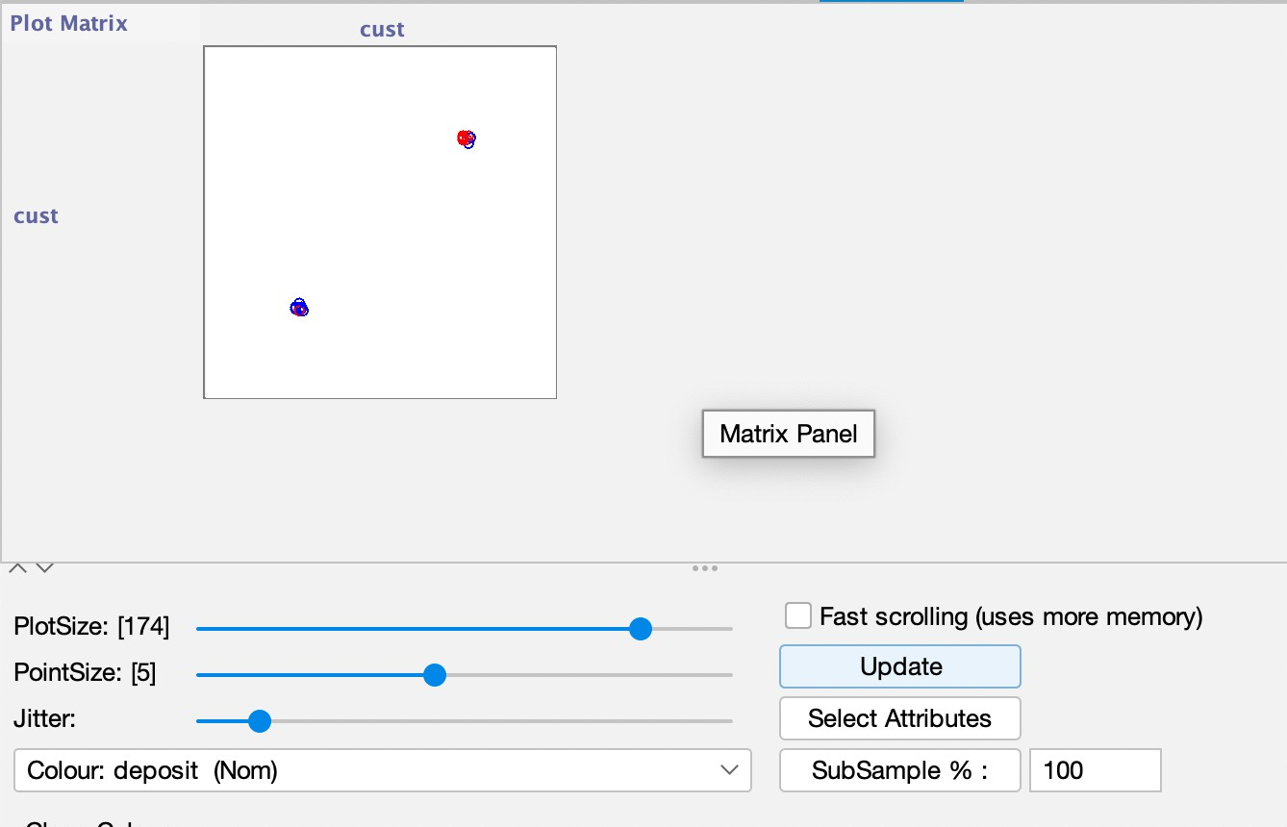

**Attribute : Account no**

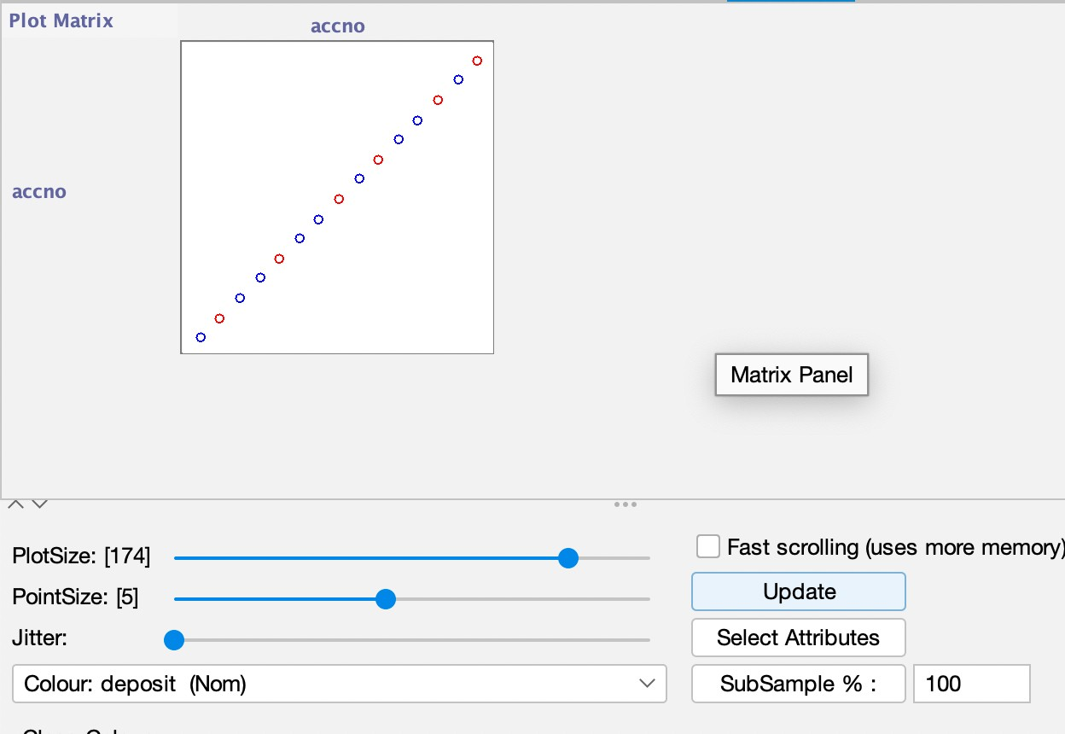

**Attribute : Location**

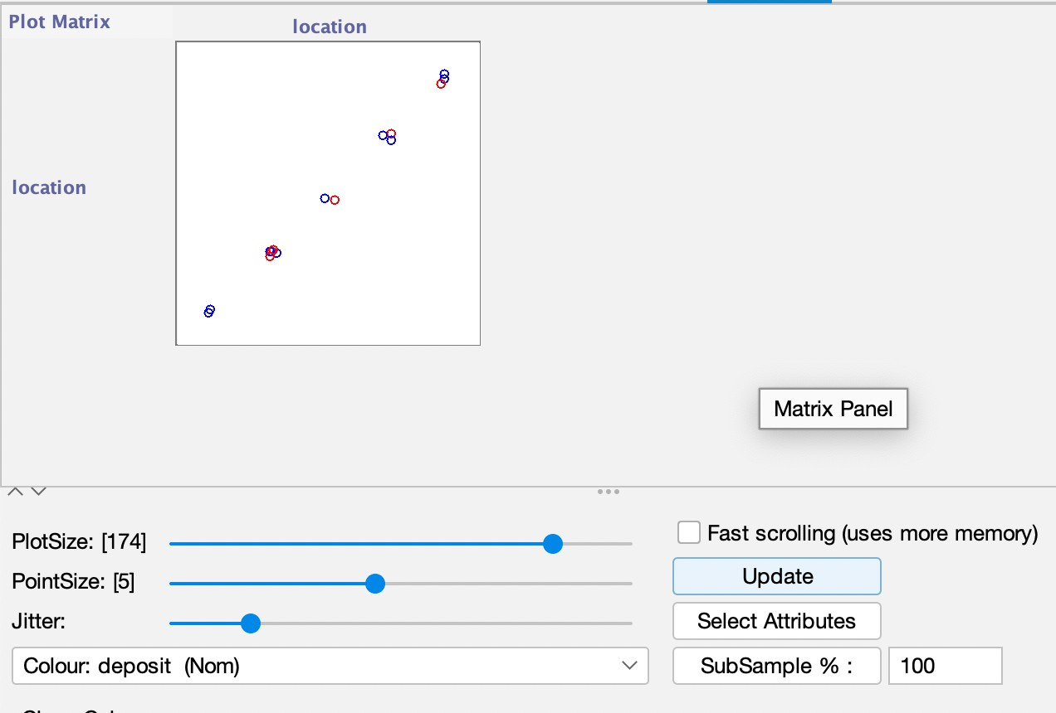

**Conclusion :**

We performed Visualisation on various attributes and changes in jitter and visualisation.

# **Practical – 7a**

## Aim Of Experiment :

Implement 1R algorithm.

**Description :**

**One Rule Algorithm**

OneR, short for "One Rule", is a simple, yet accurate, classification algorithm that generates one rule for each predictor in the data, then selects the rule with the smallest total error as its "one rule".

To create a rule for a predictor, we construct a frequency table for each predictor against the target. It has been shown that OneR produces rules only slightly less accurate than state-of- the-art classification algorithms while producing rules that are simple for humans to interpret.

#### Procedure

*# For each predictor,*

*# For each value of that predictor, make a rule as follows; # Count how often each value of target (class) appears # Find the most frequent class*

*# Make the rule assign that class to this value of the predictor # Calculate the total error of the rules of each predictor*

*# Choose the predictor with the smallest total error.*

## 1R Python Implementation:

import numpy as np import pandas as pd

df = pd.read_csv("data.csv") df.head()

Outlook Temp Humidity Windy Play Golf

* 1. Rainy Hot High False No
  2. Rainy Hot High True No
  3. Overcast Hot High False Yes
  4. Sunny Mild High False Yes
  5. Sunny Cool Normal False Yes df.shape

(14, 5)

**class** OneR:

**def** init (self): self.rule = None self.accuracy = 0.0 self.classes = []

**def** fit(self, X_train,y_train):

**if** len(X_train)!=len(y_train):

**raise** Exception("Invalid training data")

X_train = np.array(X_train).T y_train = np.array(y_train) training_samples = len(y_train)

self.classes = list(np.unique(y_train))

**if** len(self.classes)!=2:

**raise** Exception("Algorithm is made for binary classification only")

accuracy = 0.0

**for** idx,column **in** enumerate(X_train):

data = {k:{key:0 **for** key **in** self.classes} **for** k **in** np.unique(column)}

**for** d,y **in** zip(column,y_train): data[d][y]+=1

data = pd.DataFrame(data) correct_samples = 0

rule = {}

**for** col **in** data.columns: prediction = np.argmax(data[col]) rule[col] = prediction

correct_samples+= data[col][prediction] accuracy = correct_samples/training_samples **if** accuracy>self.accuracy:

self.accuracy = accuracy self.rule = idx,rule

**return** self.rule

**def** predict(self,X_test): X_test = np.array(X_test) **if not** self.rule:

**raise** Exception("Model not trained") idx,rule = self.rule

y_pred = []

**for** itr **in** X_test: y_pred.append(rule[itr[idx]])

**return** y_pred

**def** evaluate(self,X_test,y_test):

**if** len(X_test)!=len(y_test):

**raise** Exception("Invalid data") y_pred = self.predict(X_test) correct = 0

total = len(y_test)

**for** pred,actual **in** zip(y_pred,y_test):

**if** self.classes[pred]==actual: correct+=1

**return** correct/total

y = df['Play Golf']

X = df.drop('Play Golf',axis=1)

model = OneR()

model.fit(X,Y)

(0, {'Overcast': 1, 'Rainy': 0, 'Sunny': 1}) model.accuracy

0.7142857142857143

## 1R Weka Implementation:

1. Open Weka and load the Weather.arff Dataset in the Explorer.
2. Open the Classify Tab on top .
3. Click on Choose Button
4. Under Rules Click on **OneR** Algorithm
5. Choose Test Option as training set itself.
6. Choose (Nom) Play as the target variable.
7. Click start.

**Result**

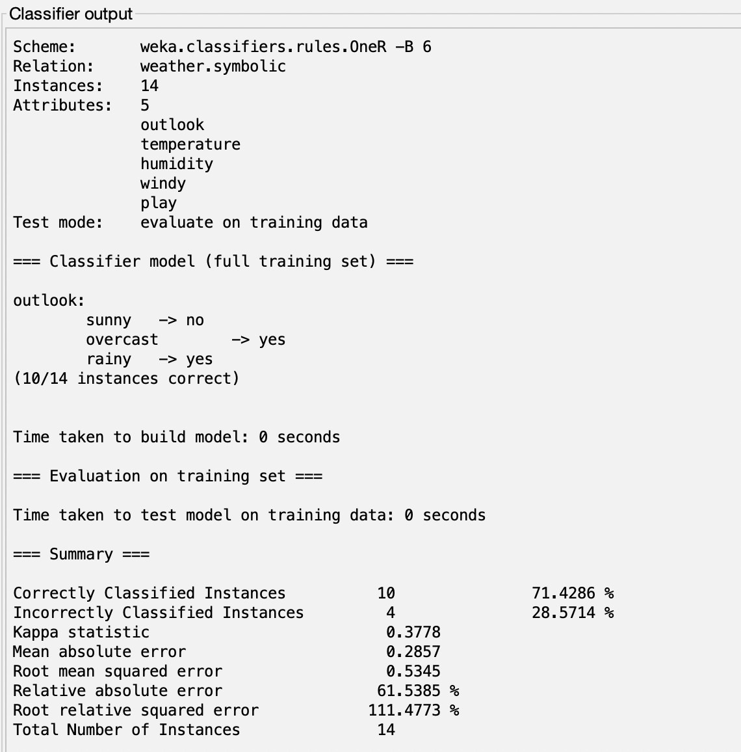

**Conclusion:**

We Implemented One Rule algorithm using Python and Weka to classify the Weather data.

**Practical – 7b**

**Aim Of Experiment :**

Implement Decision Tree.

**Description :**

**Decision Tree**

A decision tree is a classification and prediction tool having a tree-like structure, where each internal node denotes a test on an attribute, each branch represents an outcome of the test, and each leaf node (terminal node) holds a class label-

*A decision tree is a tree where each -*

* Node - a feature(attribute)
* Branch - a decision(rule)
* Leaf - an outcome(categorical or continuous)

There are many algorithms there to build a decision tree. They are

* 1. **CART** (Classification and Regression Trees) — This makes use of Gini impurity as the metric.
  2. **ID3** (Iterative Dichotomiser 3) — This uses entropy and information gain as metric.

Python Implementation

import pandas as pd

df = pd.read_csv("salaries.csv") df.head()

| company | job | degree | salary_more_then_100k |
| --- | --- | --- | --- |
| 0 google | sales executive | bachelors | 0 |
| 1 google | sales executive | masters | 0 |
| 2 google | business manager | bachelors | 1 |
| 3 google | business manager | masters | 1 |
| 4 google | computer programmer | bachelors | 0 |

inputs = df.drop('salary_more_then_100k',axis='columns') target = df['salary_more_then_100k']

from sklearn.preprocessing import LabelEncoder le_company = LabelEncoder()

le_job = LabelEncoder() le_degree = LabelEncoder()

inputs['company_n'] = le_company.fit_transform(inputs['company']) inputs['job_n'] = le_job.fit_transform(inputs['job']) inputs['degree_n'] = le_degree.fit_transform(inputs['degree'])

inputs

company job degree company_n job_n degree_n

1. google sales executive bachelors 2 2 0
2. google sales executive masters 2 2 1
3. google business manager bachelors 2 0 0
4. google business manager masters 2 0 1
5. google computer programmer bachelors 2 1 0
6. google computer programmer masters 2 1 1
7. abc pharma sales executive masters 0 2 1
8. abc pharma computer programmer bachelors 0 1 0
9. abc pharma business manager bachelors 0 0 0
10. abc pharma business manager masters 0 0 1
11. facebook sales executive bachelors 1 2 0
12. facebook sales executive masters 1 2 1
13. facebook business manager bachelors 1 0 0
14. facebook business manager masters 1 0 1
15. facebook computer programmer bachelors 1 1 0
16. facebook computer programmer masters 1 1 1

inputs_n = inputs.drop(['company','job','degree'],axis='columns') inputs_n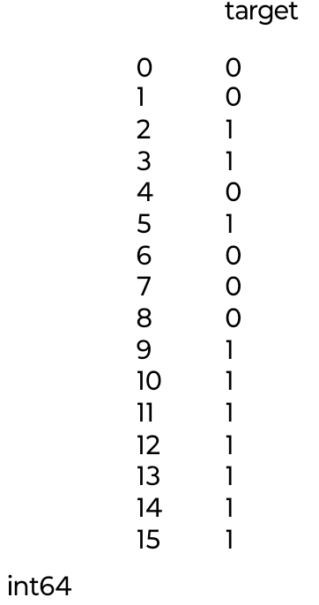

|  | company_n | job_n | degree_n |
| --- | --- | --- | --- |
| 0 | 2 | 2 | 0 |
| 1 | 2 | 2 | 1 |
| 2 | 2 | 0 | 0 |
| 3 | 2 | 0 | 1 |
| 4 | 2 | 1 | 0 |
| 5 | 2 | 1 | 1 |
| 6 | 0 | 2 | 1 |
| 7 | 0 | 1 | 0 |
| 8 | 0 | 0 | 0 |
| 9 | 0 | 0 | 1 |
| 10 | 1 | 2 | 0 |
| 11 | 1 | 2 | 1 |
| 12 | 1 | 0 | 0 |
| 13 | 1 | 0 | 1 |
| 14 | 1 | 1 | 0 |
| 15 | 1 | 1 | 1 |

Name: salary_more_then_100k, dtype:

from sklearn.model_selection import train_test_split

X_train, X_test, y_train, y_test = train_test_split(inputs_n,target,test_size=0.3)

from sklearn import tree

model = tree.DecisionTreeClassifier() model.fit(X_train,y_train) DecisionTreeClassifier() model.score(X_test,y_test)

0.8

Decision Tree Using WEKA:

1. Open Weka and load the Weather_numeric.csv Dataset in the Explorer.
2. Open the Classify Tab on top .
3. Click on Choose Button
4. Under Tree Click on **J48** Algorithm
5. Choose Test Option as Cross Validation -fold 10.
6. Choose (Nom) Play as the target variable.
7. Click start.

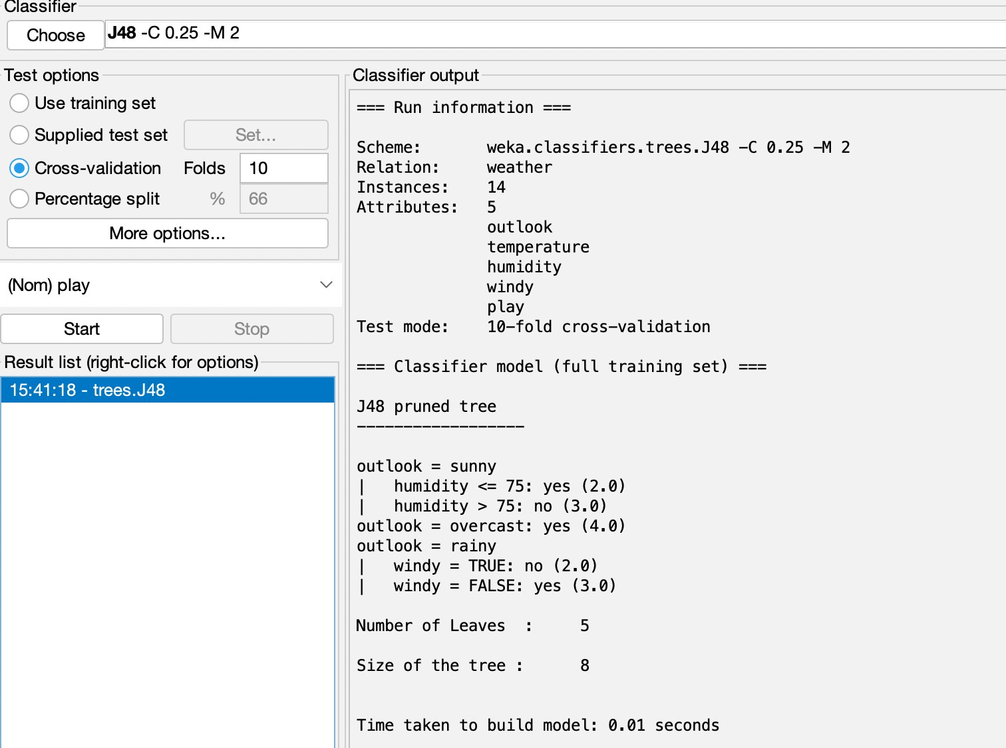

* Right Click on Result
* Visualise the Tree

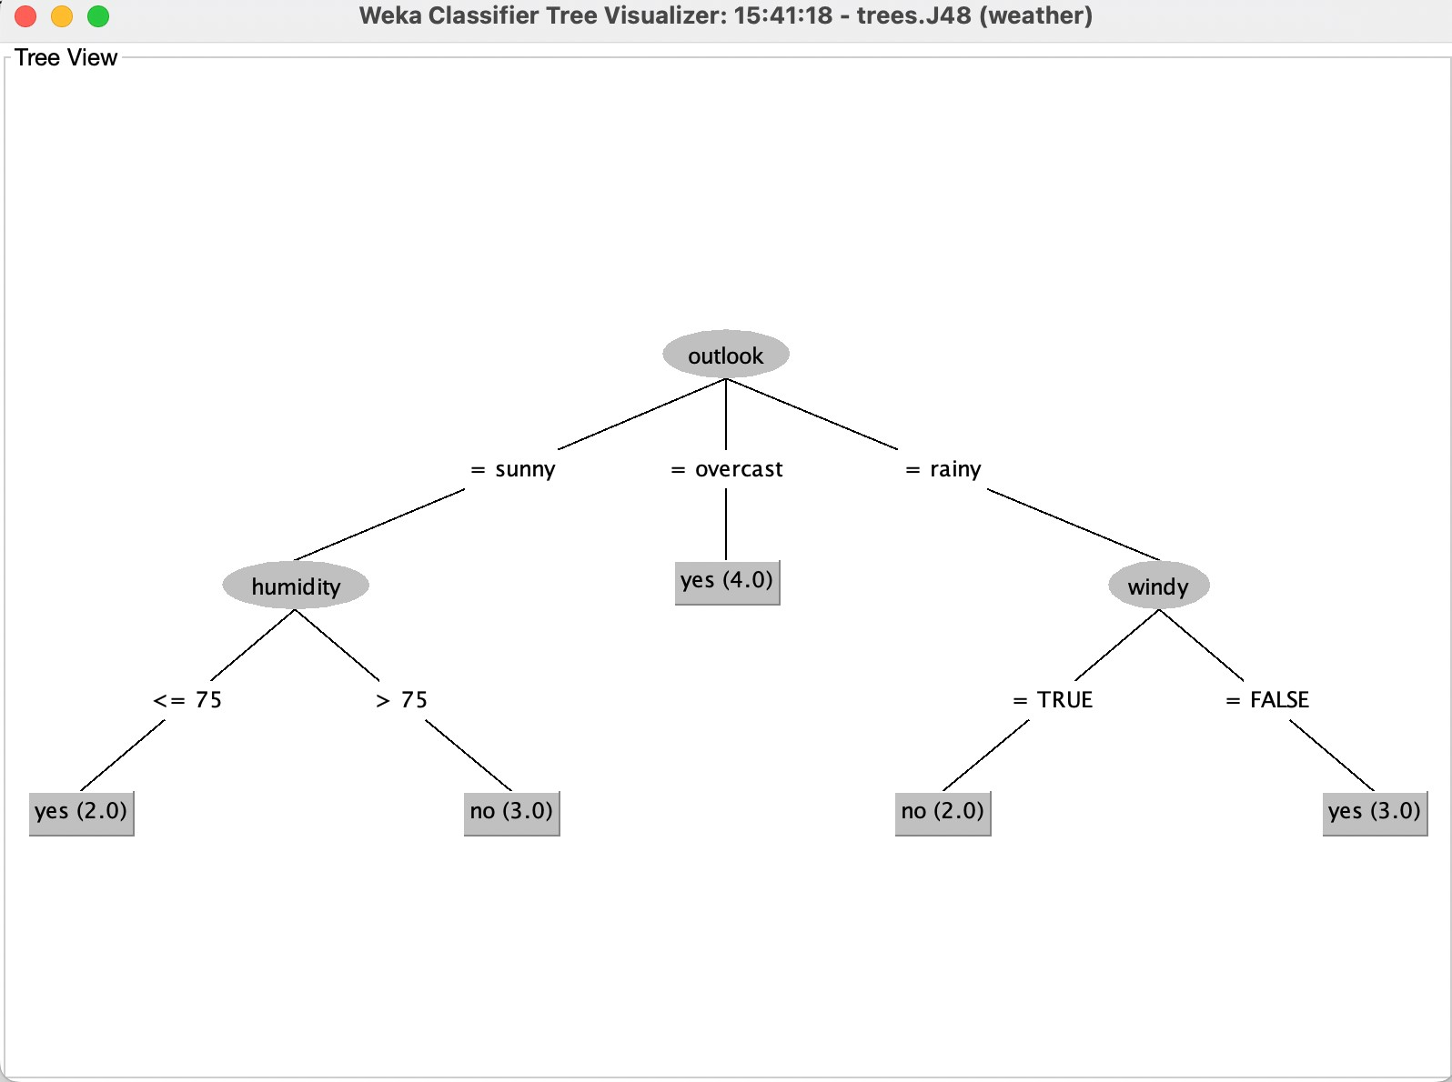

**Conclusion:**

We Implemented Decision Tree Algorithm in python and in WEKA.

**Practical – 8a**

**Aim Of Experiment :**

Implement Naïve Bayes Classifier.

**Description :**

**Naïve Bayes Algorithm**

* Naïve Bayes algorithm is a supervised learning algorithm, which is based on **Bayes theorem** and used for solving classification problems.
* It is mainly used in *text classification* that includes a high-dimensional training dataset.
* Naïve Bayes Classifier is one of the simple and most effective Classification algorithms which helps in building the fast machine learning models that can make quick predictions.
* **It is a probabilistic classifier, which means it predicts on the basis of the probability of an object**.
* Some popular examples of Naïve Bayes Algorithm are **spam filtration, Sentimental analysis, and classifying articles**.

**Bayes Theorem**

* Bayes' theorem is also known as **Bayes' Rule** or **Bayes' law**, which is used to determine the probability of a hypothesis with prior knowledge. It depends on the conditional probability.
* The formula for Bayes' theorem is given as:

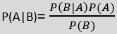

**Where,**

**P(A|B) is Posterior probability**: Probability of hypothesis A on the observed event B.

**P(B|A) is Likelihood probability**: Probability of the evidence given that the probability of a hypothesis is true.

**P(A) is Prior Probability**: Probability of hypothesis before observing the evidence.

**P(B) is Marginal Probability**: Probability of Evidence.

### Python Implementation

import pandas as pd

df = pd.read_csv("titanic.csv") df.head()

| PassengerId  0 1 | |  | Name Pclass \ Braund, Mr. Owen Harris 3 | |
| --- | --- | --- | --- | --- |
| 1 | 2 | Cumings, Mrs. | John Bradley (Florence Briggs Th... | 1 |
| 2 | 3 |  | Heikkinen, Miss. Laina | 3 |
| 3 | 4 | Futrelle, | Mrs. Jacques Heath (Lily May Peel) | 1 |
| 4 | 5 |  | Allen, Mr. William Henry | 3 |

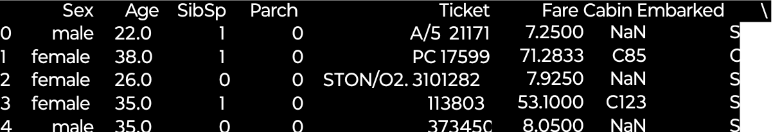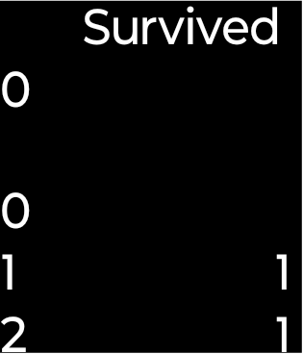

df.drop(['PassengerId','Name','SibSp','Parch','Ticket','Cabin','Embarked'],axis='colum ns',inplace=True)

df.head()

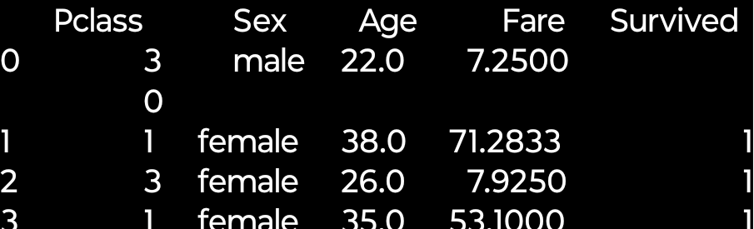

inputs = df.drop('Survived',axis='columns') target = df.Survived

*#inputs.Sex = inputs.Sex.map({'male': 1, 'female': 2})*

dummies = pd.get_dummies(inputs.Sex) dummies.head(3)

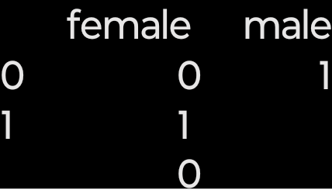

inputs = pd.concat([inputs,dummies],axis='columns') inputs.head(3)

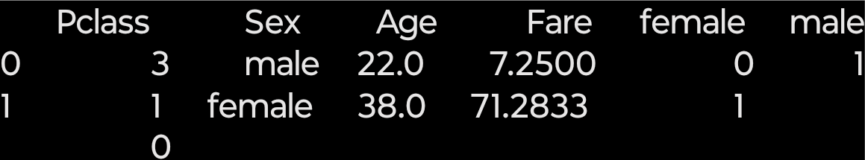

inputs.drop(['Sex','male'],axis='columns',inplace=True) inputs.head(3)

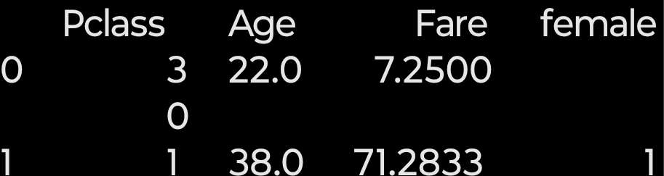

inputs.columns[inputs.isna().any()] Index(['Age'], dtype='object') inputs.Age[:10]

0 22.0

1 38.0

2 26.0

3 35.0

4 35.0

5 NaN

6 54.0

7 2.0

8 27.0

9 14.0

Name: Age, dtype: float64

inputs.Age = inputs.Age.fillna(inputs.Age.mean()) inputs.head()

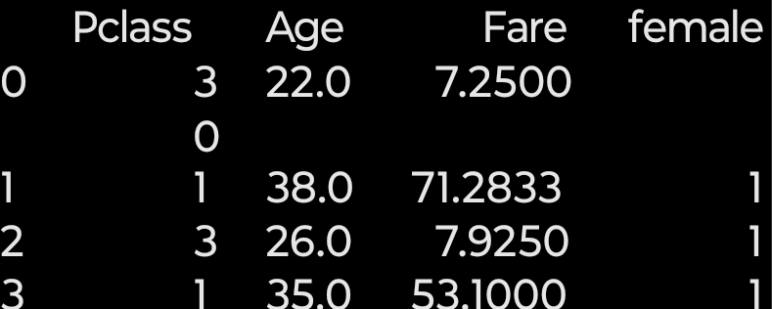

from sklearn.model_selection import train_test_split

X_train, X_test, y_train, y_test = train_test_split(inputs,target,test_size=0.3)

from sklearn.naive_bayes import GaussianNB model = GaussianNB()

model.fit(X_train,y_train) GaussianNB(priors=None, var_smoothing=1e-09) model.score(X_test,y_test)

0.7835820895522388

X_test[0:10]

|  | Pclass | Age | Fare | female | male |
| --- | --- | --- | --- | --- | --- |
| 309 | 1 | 30.000000 | 56.9292 | 1 | 0 |
| 839 | 1 | 29.699118 | 29.7000 | 0 | 1 |
| 110 | 1 | 47.000000 | 52.0000 | 0 | 1 |
| 872 | 1 | 33.000000 | 5.0000 | 0 | 1 |
| 235 | 3 | 29.699118 | 7.5500 | 1 | 0 |
| 411 | 3 | 29.699118 | 6.8583 | 0 | 1 |
| 32 | 3 | 29.699118 | 7.7500 | 1 | 0 |
| 562 | 2 | 28.000000 | 13.5000 | 0 | 1 |
| 542 | 3 | 11.000000 | 31.2750 | 1 | 0 |
| 250 | 3 | 29.699118 | 7.2500 | 0 | 1 |

y_test[0:10]

309 1

839 1

110 0

872 0

235 0

411 0

32 1

562 0

542 0

250 0

Name: Survived, dtype: int64 model.predict(X_test[0:10])

array([1, 0, 0, 0, 1, 0, 1, 0, 1, 0], dtype=int64) model.predict_proba(X_test[:10])

| array([[0.00455992, | 0.99544008], |
| --- | --- |
| [0.91382024, | 0.08617976], |
| [0.88164575, | 0.11835425], |
| [0.92347978, | 0.07652022], |
| [0.09084386, | 0.90915614], |
| [0.99093305, | 0.00906695], |
| [0.09094857, | 0.90905143], |
| [0.97923786, | 0.02076214], |
| [0.0516967 , | 0.9483033 ], |
| [0.9909573 , | 0.0090427 ]]) |

**Calculate the score using cross validation**

from sklearn.model_selection import cross_val_score cross_val_score(GaussianNB(),X_train, y_train, cv=5)

array([0.75396825, 0.784 , 0.76612903, 0.82258065, 0.77419355])

## WEKA Implementation

1. Open Weka Application
2. Open the Explorer Window and Click on open file.
3. Under the data files Open the diabetes.arff file.
4. Click On edit to View the Dataset.

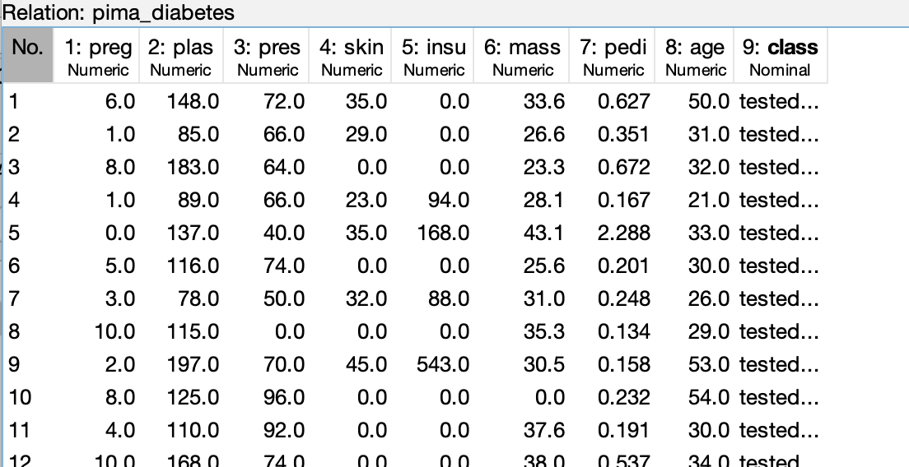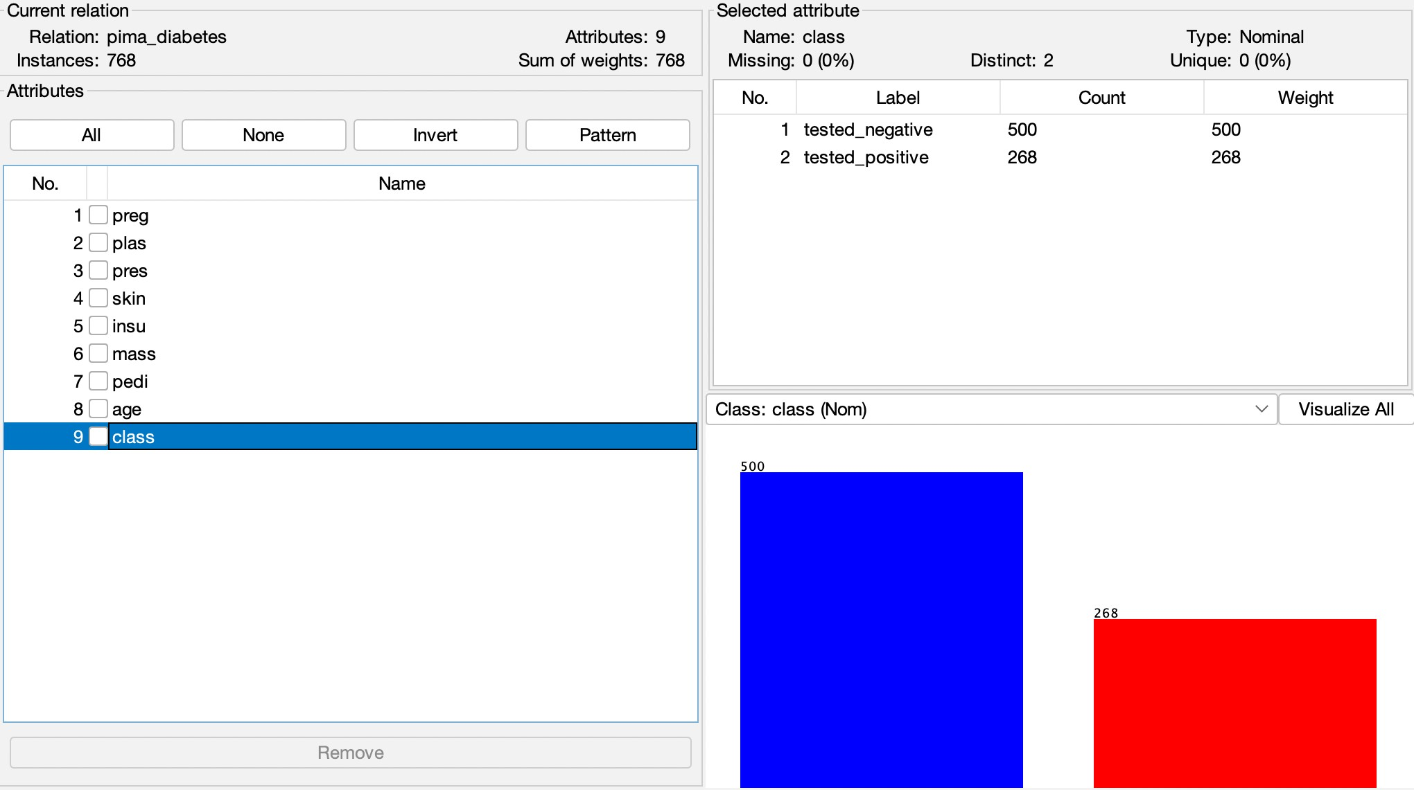

1. Switch to the classify tab.
2. Under the classify tab click on choose
3. Choose the bayes folder and select Naïve Bayes.

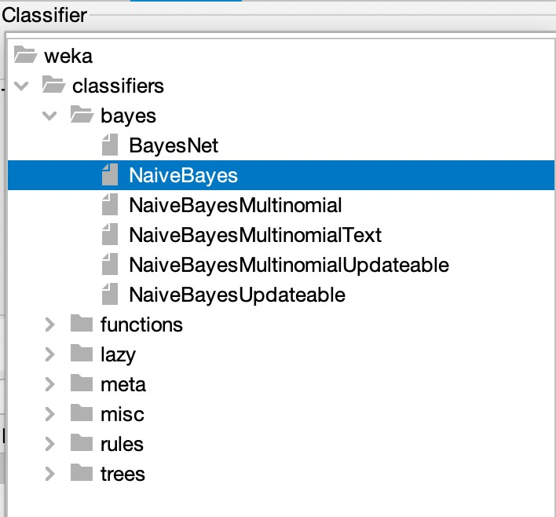

1. Choose 10 fold cross validation as test Option
2. Click on Start to build the model

**Result :**

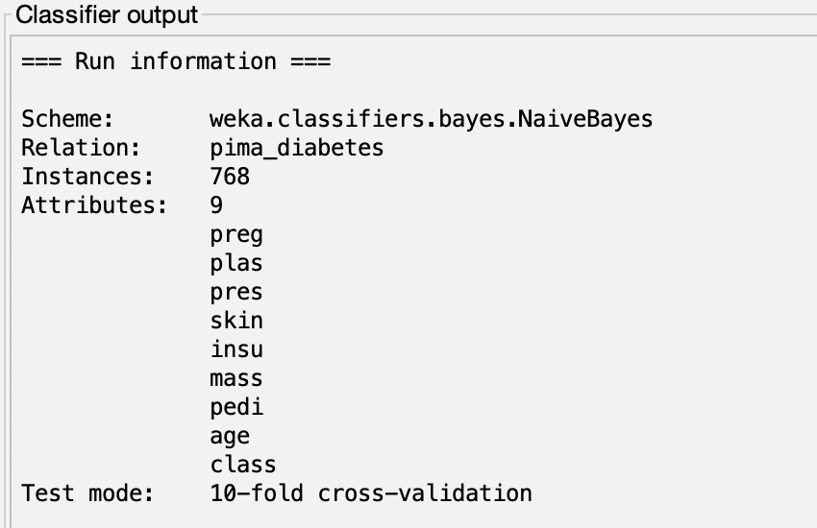

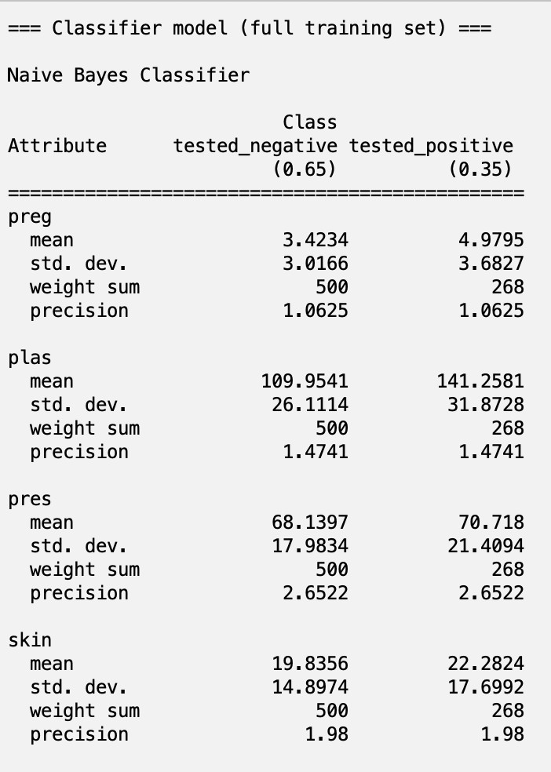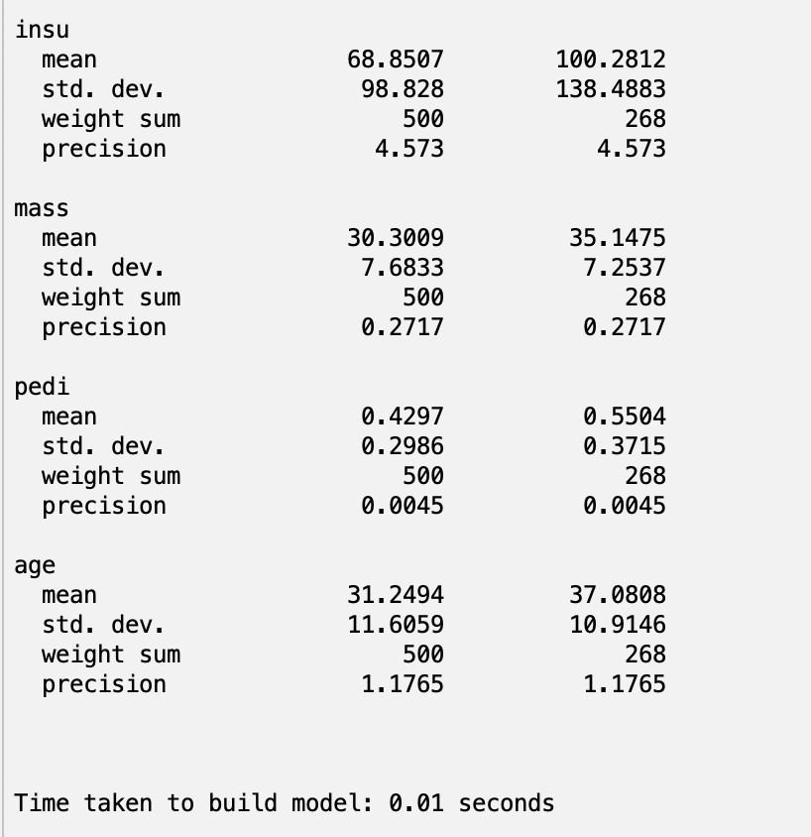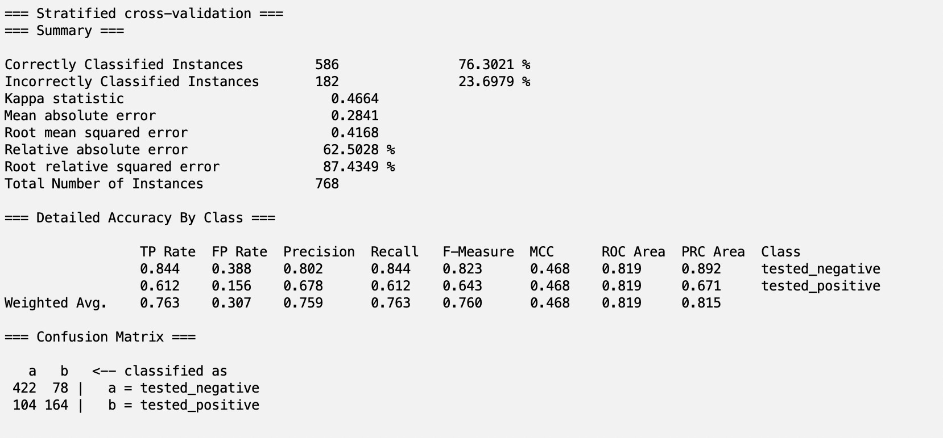

**Conclusion:**

We implemented the Naïve Bayes Classifier using Python on titanic Dataset and Using Weka using Diabetes dataset.

**Practical – 8b**

**Aim Of Experiment :**

Implement Random Forest .

**Description :**

**Random Forest Algorithm**

Random Forest is a popular machine learning algorithm that belongs to the supervised learning technique. It can be used for both Classification and Regression problems in ML. It is based on the concept of **ensemble learning,** which is a process of *combining multiple classifiers to solve a complex problem and to improve the performance of the model.*

As the name suggests, ***"Random Forest is a classifier that contains a number of decision trees on various subsets of the given dataset and takes the average to improve the predictive accuracy of that dataset."*** Instead of relying on one decision tree, the random forest takes the prediction from each tree and based on the majority votes of predictions, and it predicts the final output.

#### The greater number of trees in the forest leads to higher accuracy and prevents the problem of overfitting.

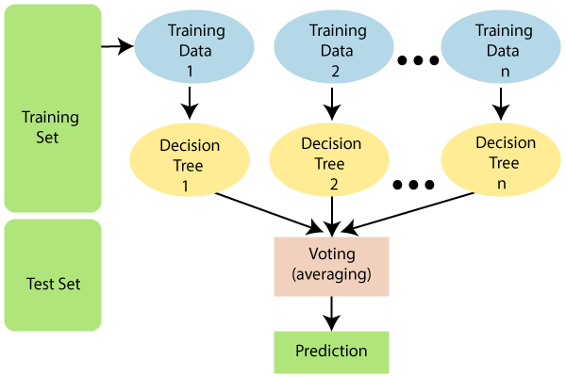

The Working process can be explained in the below steps and diagram:

**Step-1:** Select random K data points from the training set.

**Step-2:** Build the decision trees associated with the selected data points (Subsets).

**Step-3:** Choose the number N for decision trees that you want to build.

**Step-4:** Repeat Step 1 & 2.

**Step-5:** For new data points, find the predictions of each decision tree, and assign the new data points to the category that wins the majority votes.

Random Forest is capable of performing both Classification and Regression tasks. It is capable of handling large datasets with high dimensionality.

It enhances the accuracy of the model and prevents the overfitting issue.

**Python Implementation**

**Digits dataset from sklearn**

import pandas as pd

from sklearn.datasets import load_digits digits = load_digits()

dir(digits)

['DESCR', 'data', 'images', 'target', 'target_names']

%matplotlib inline

import matplotlib.pyplot as plt

plt.gray()

**for** i **in** range(4): plt.matshow(digits.images[i])

<matplotlib.figure.Figure at 0x2406e6b9a90>

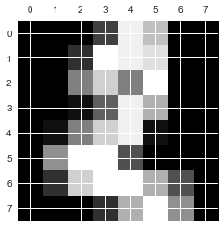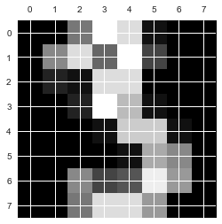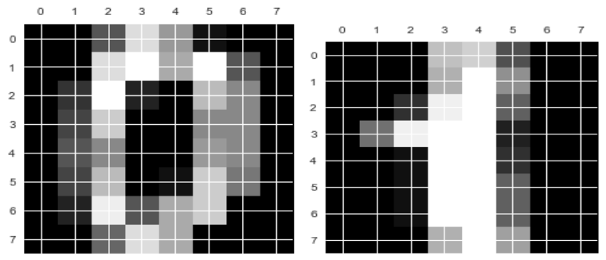

df = pd.DataFrame(digits.data) df.head()

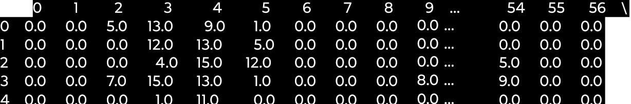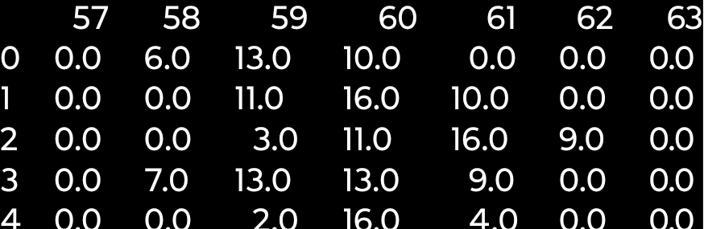

[5 rows x 64 columns]

df['target'] = digits.target df[0:12]

|  | 0 | 1 | 2 | 3 | 4 | 5 | 6 | 7 | 8 | 9 | ... | 55 | 56 | \ |
| --- | --- | --- | --- | --- | --- | --- | --- | --- | --- | --- | --- | --- | --- | --- |
| 0 | 0.0 | 0.0 | 5.0 | 13.0 | 9.0 | 1.0 | 0.0 | 0.0 | 0.0 | 0.0 | ... | 0.0 | 0.0 |  |
| 1 | 0.0 | 0.0 | 0.0 | 12.0 | 13.0 | 5.0 | 0.0 | 0.0 | 0.0 | 0.0 | ... | 0.0 | 0.0 |  |
| 2 | 0.0 | 0.0 | 0.0 | 4.0 | 15.0 | 12.0 | 0.0 | 0.0 | 0.0 | 0.0 | ... | 0.0 | 0.0 |  |
| 3 | 0.0 | 0.0 | 7.0 | 15.0 | 13.0 | 1.0 | 0.0 | 0.0 | 0.0 | 8.0 | ... | 0.0 | 0.0 |  |
| 4 | 0.0 | 0.0 | 0.0 | 1.0 | 11.0 | 0.0 | 0.0 | 0.0 | 0.0 | 0.0 | ... | 0.0 | 0.0 |  |
| 5 | 0.0 | 0.0 | 12.0 | 10.0 | 0.0 | 0.0 | 0.0 | 0.0 | 0.0 | 0.0 | ... | 0.0 | 0.0 |  |
| 6 | 0.0 | 0.0 | 0.0 | 12.0 | 13.0 | 0.0 | 0.0 | 0.0 | 0.0 | 0.0 | ... | 0.0 | 0.0 |  |
| 7 | 0.0 | 0.0 | 7.0 | 8.0 | 13.0 | 16.0 | 15.0 | 1.0 | 0.0 | 0.0 | ... | 0.0 | 0.0 |  |
| 8 | 0.0 | 0.0 | 9.0 | 14.0 | 8.0 | 1.0 | 0.0 | 0.0 | 0.0 | 0.0 | ... | 0.0 | 0.0 |  |
| 9 | 0.0 | 0.0 | 11.0 | 12.0 | 0.0 | 0.0 | 0.0 | 0.0 | 0.0 | 2.0 | ... | 0.0 | 0.0 |  |
| 10 | 0.0 | 0.0 | 1.0 | 9.0 | 15.0 | 11.0 | 0.0 | 0.0 | 0.0 | 0.0 | ... | 0.0 | 0.0 |  |
| 11 | 0.0 | 0.0 | 0.0 | 0.0 | 14.0 | 13.0 | 1.0 | 0.0 | 0.0 | 0.0 | ... | 0.0 | 0.0 |  |

|  | 57 | 58 | 59 | 60 | 61 | 62 | 63 | target |
| --- | --- | --- | --- | --- | --- | --- | --- | --- |
| 0 | 0.0 | 6.0 | 13.0 | 10.0 | 0.0 | 0.0 | 0.0 | 0 |
| 1 | 0.0 | 0.0 | 11.0 | 16.0 | 10.0 | 0.0 | 0.0 | 1 |
| 2 | 0.0 | 0.0 | 3.0 | 11.0 | 16.0 | 9.0 | 0.0 | 2 |
| 3 | 0.0 | 7.0 | 13.0 | 13.0 | 9.0 | 0.0 | 0.0 | 3 |
| 4 | 0.0 | 0.0 | 2.0 | 16.0 | 4.0 | 0.0 | 0.0 | 4 |
| 5 | 0.0 | 9.0 | 16.0 | 16.0 | 10.0 | 0.0 | 0.0 | 5 |
| 6 | 0.0 | 1.0 | 9.0 | 15.0 | 11.0 | 3.0 | 0.0 | 6 |
| 7 | 0.0 | 13.0 | 5.0 | 0.0 | 0.0 | 0.0 | 0.0 | 7 |
| 8 | 0.0 | 11.0 | 16.0 | 15.0 | 11.0 | 1.0 | 0.0 | 8 |
| 9 | 0.0 | 9.0 | 12.0 | 13.0 | 3.0 | 0.0 | 0.0 | 9 |
| 10 | 0.0 | 1.0 | 10.0 | 13.0 | 3.0 | 0.0 | 0.0 | 0 |
| 11 | 0.0 | 0.0 | 1.0 | 13.0 | 16.0 | 1.0 | 0.0 | 1 |

[12 rows x 65 columns]

**Train and the model and prediction**

X = df.drop('target',axis='columns') y = df.target

from sklearn.model_selection import train_test_split

X_train, X_test, y_train, y_test = train_test_split(X,y,test_size=0.2)

from sklearn.ensemble import RandomForestClassifier model = RandomForestClassifier(n_estimators=20) model.fit(X_train, y_train)

RandomForestClassifier(bootstrap=True, class_weight=None, criterion='gini', max_depth=None, max_features='auto', max_leaf_nodes=None, min_impurity_split=1e-07, min_samples_leaf=1, min_samples_split=2, min_weight_fraction_leaf=0.0, n_estimators=20, n_jobs=1, oob_score=False, random_state=None, verbose=0, warm_start=False)

model.score(X_test, y_test)

0.96666666666666667

y_predicted = model.predict(X_test)

**Confusion Matrix**

from sklearn.metrics import confusion_matrix cm = confusion_matrix(y_test, y_predicted) cm

| array([[34, | 0, | 0, | 0, | 0, | 0, | 0, | 0, | 0, | 0], |
| --- | --- | --- | --- | --- | --- | --- | --- | --- | --- |
| [ 0, | 30, | 0, | 0, | 0, | 0, | 0, | 0, | 0, | 0], |
| [ 0, | 1, | 38, | 0, | 0, | 0, | 0, | 0, | 0, | 0], |
| [ 0, | 0, | 0, | 30, | 0, | 1, | 0, | 0, | 0, | 0], |
| [ 0, | 0, | 0, | 0, | 39, | 0, | 0, | 1, | 0, | 0], |
| [ 0, | 0, | 0, | 0, | 0, | 25, | 0, | 0, | 0, | 0], |
| [ 1, | 0, | 0, | 0, | 0, | 1, | 45, | 0, | 0, | 0], |
| [ 0, | 0, | 0, | 0, | 0, | 0, | 0, | 38, | 0, | 0], |
| [ 0, | 1, | 1, | 0, | 0, | 0, | 0, | 0, | 33, | 0], |
| [ 0, | 1, | 0, | 1, | 0, | 1, | 0, | 2, | 0, | 36]]) |

%matplotlib inline

import matplotlib.pyplot as plt import seaborn as sn plt.figure(figsize=(10,7)) sn.heatmap(cm, annot=True) plt.xlabel('Predicted') plt.ylabel('Truth')

<matplotlib.text.Text at 0x2406e03e080>

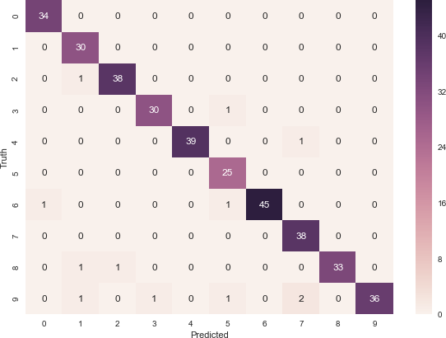

## WEKA Implementation

1. Open Weka Application
2. Open the Explorer Window and Click on open file.
3. Under the data files Open the Weather_numeric.arff file.
4. Click On edit to View the Dataset.

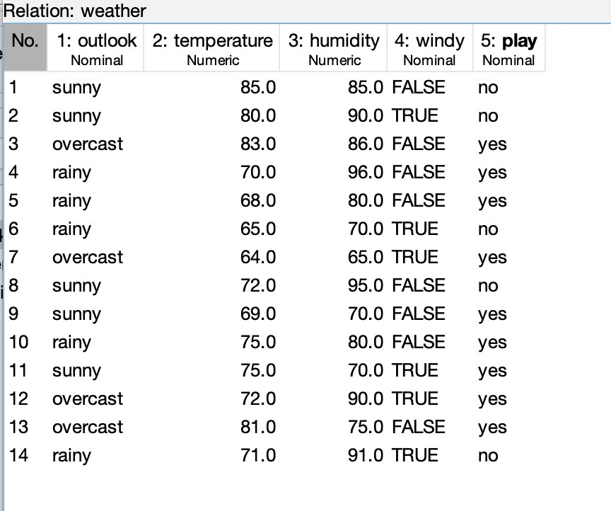

1. Switch to the classify tab.
2. Under the classify tab click on choose
3. Choose the trees folder and select Random Forest.

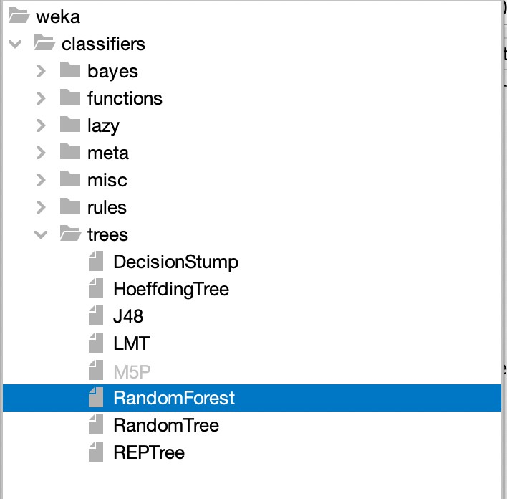 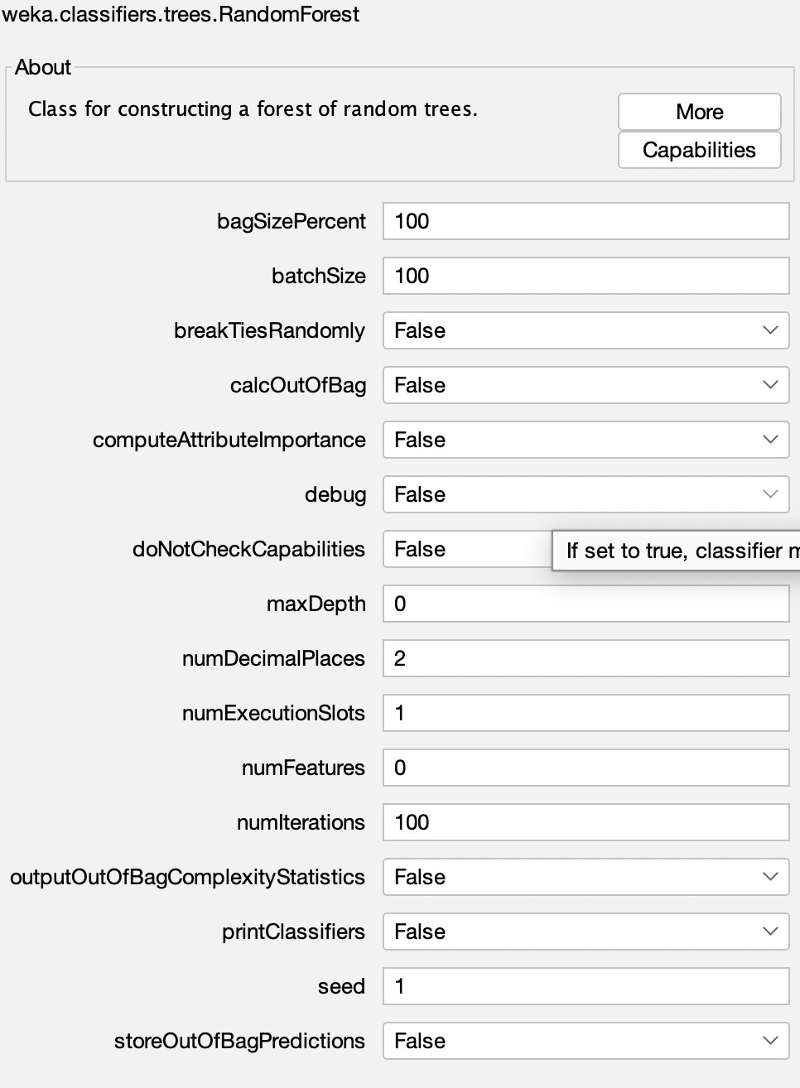

1. Choose 10 fold cross validation as test Option
2. Click on Start to build the model

**Result :**

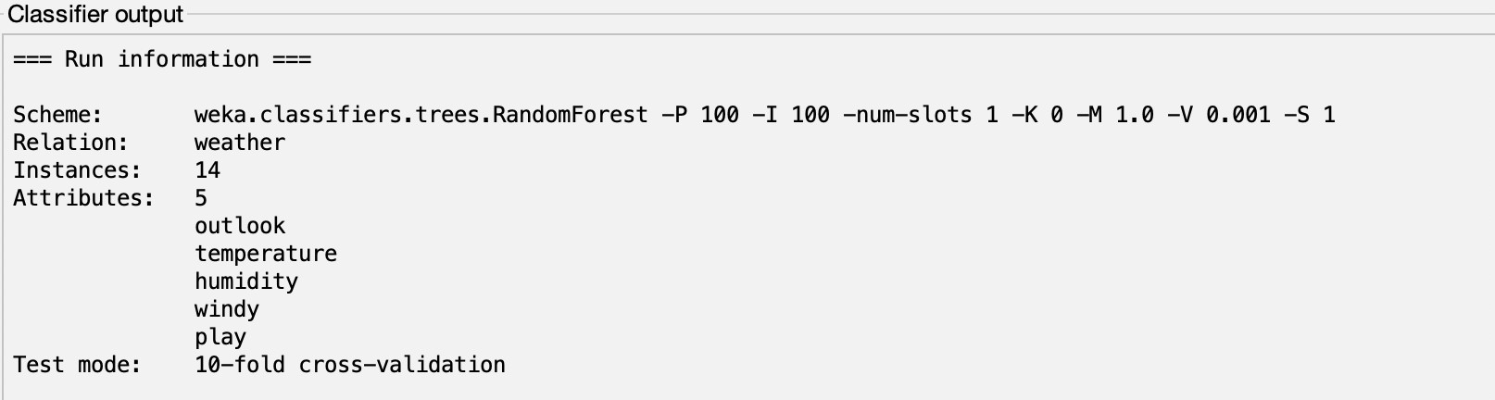

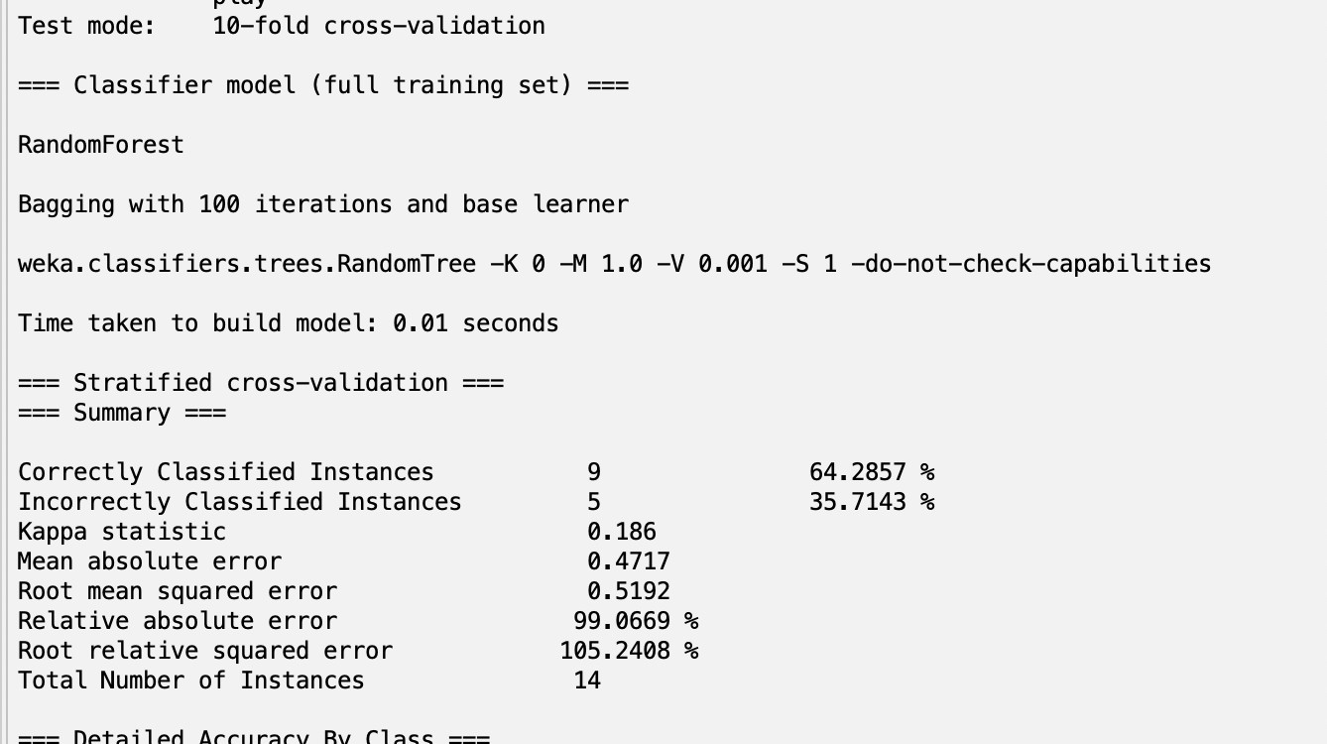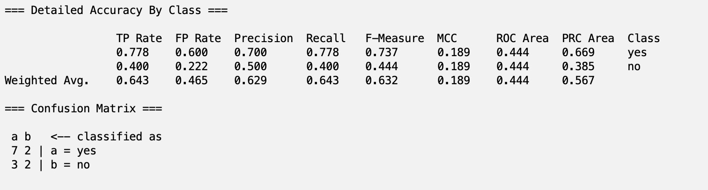

**Conclusion:**

We implemented the Naïve Bayes Classifier using Python on titanic Dataset and Using Weka using Diabetes dataset.

**Practical – 9a**

### AIM OF EXPERIMENT :

TO IMPLEMENT APRIORI ALGORITHM

**DESCRIPTION :**

**Apriori Algorithm:**

Apriori algorithm refers to the algorithm which is used to calculate the association rules between objects. It means how two or more objects are related to one another. In other words, we can say that the apriori algorithm is an association rule leaning that analyses that people who bought product A also bought product B.

The primary objective of the apriori algorithm is to create the association rule between different objects. The association rule describes how two or more objects are related to one another. Apriori algorithm is also called frequent pattern mining. Generally, you operate the Apriori algorithm on a database that consists of a huge number of transactions.

To construct association rules between elements or items, the algorithm considers 3 important factors which are, **support, confidence** and **lift.**

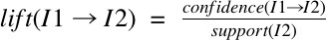

### Python Implementation

Dataset Load

dataset = [['Milk', 'Onion', 'Nutmeg', 'Kidney Beans', 'Eggs', 'Yogurt'],

['Dill', 'Onion', 'Nutmeg', 'Kidney Beans', 'Eggs', 'Yogurt'], ['Milk', 'Apple', 'Kidney Beans', 'Eggs'],

['Milk', 'Unicorn', 'Corn', 'Kidney Beans', 'Yogurt'],

['Corn', 'Onion', 'Onion', 'Kidney Beans', 'Ice cream', 'Eggs']]

Load require packages

import pandas as pd

from mlxtend.preprocessing import TransactionEncoder

Transform the data

te = TransactionEncoder()

te_try = te.fit(dataset).transform(dataset)

Generate Dataframe

df = pd.DataFrame(te_try, columns=te.columns_)

df

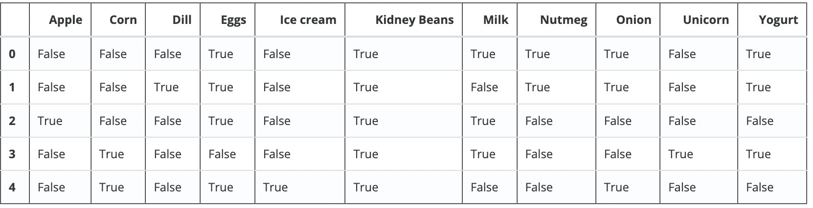

Model Training

from mlxtend.frequent_patterns import apriori apriori(df,min_support=0.5)

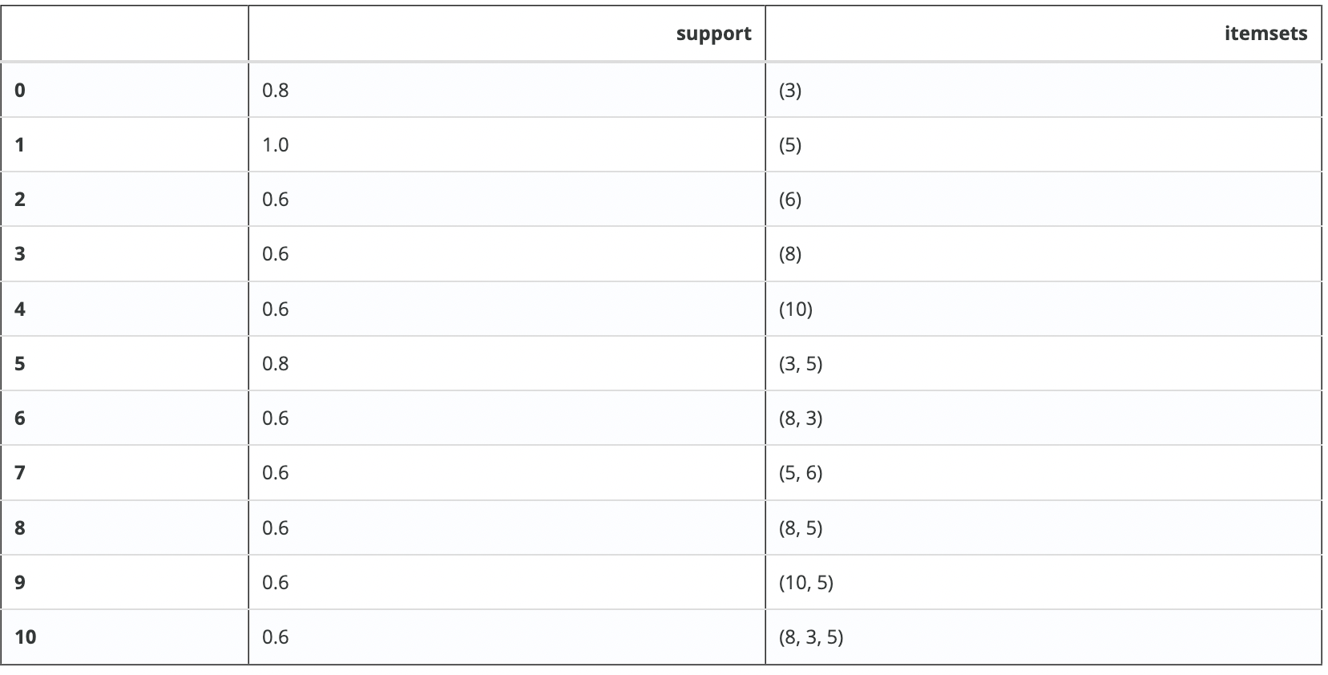

Model Training with Column Result return

apriori(df,min_support=0.5, use_colnames=True)

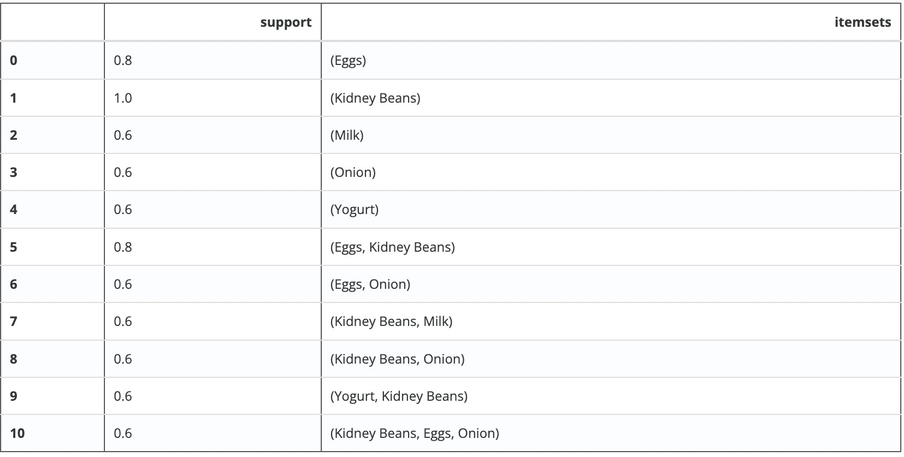

Calculate the length of Itemset

frequent_itemsets = apriori(df, min_support=0.6, use_colnames=True) frequent_itemsets['length'] = frequent_itemsets['itemsets'].apply(**lambda** x: len(x)) frequent_itemsets



Length is 2 and Support is > 0.8

frequent_itemsets[ (frequent_itemsets['length'] == 2) & (frequent_itemsets['support']

>= 0.8) ]



frequent_itemsets[ frequent_itemsets['itemsets'] == {'Onion', 'Eggs'} ]



oht_ary = te.fit(dataset).transform(dataset, sparse=True)

sparse_df = pd.SparseDataFrame(te_try, columns=te.columns_, default_fill_value=False) sparse_df

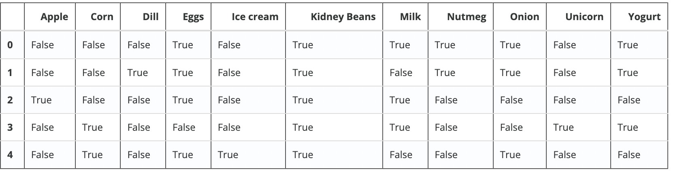

Verbose return the number of iteration and itemset default size

apriori(sparse_df, min_support=0.6, use_colnames=True, verbose=1)

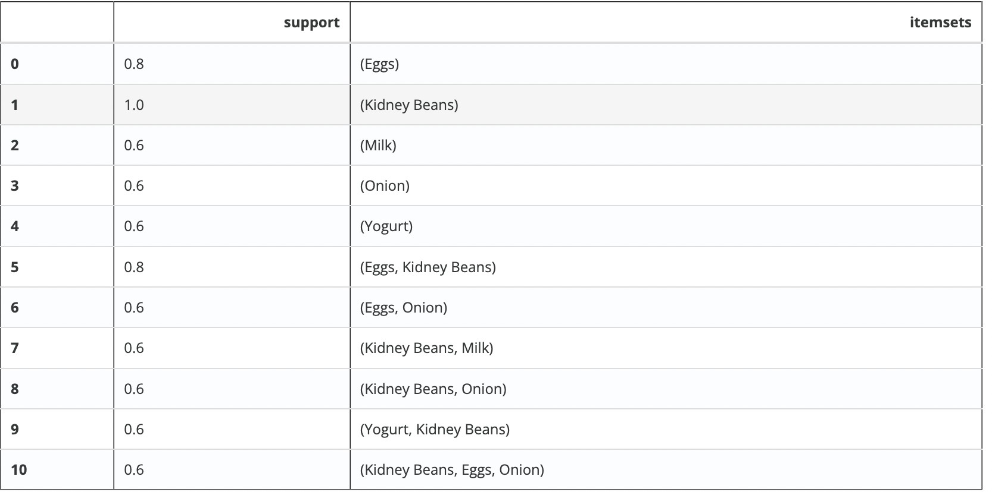

### WEKA implementation of Apriori:

1. Load the Supermarket Dataset into Explorer.
2. Open the association tab.
3. Choose Apriori algorithm for association
4. Click on start.

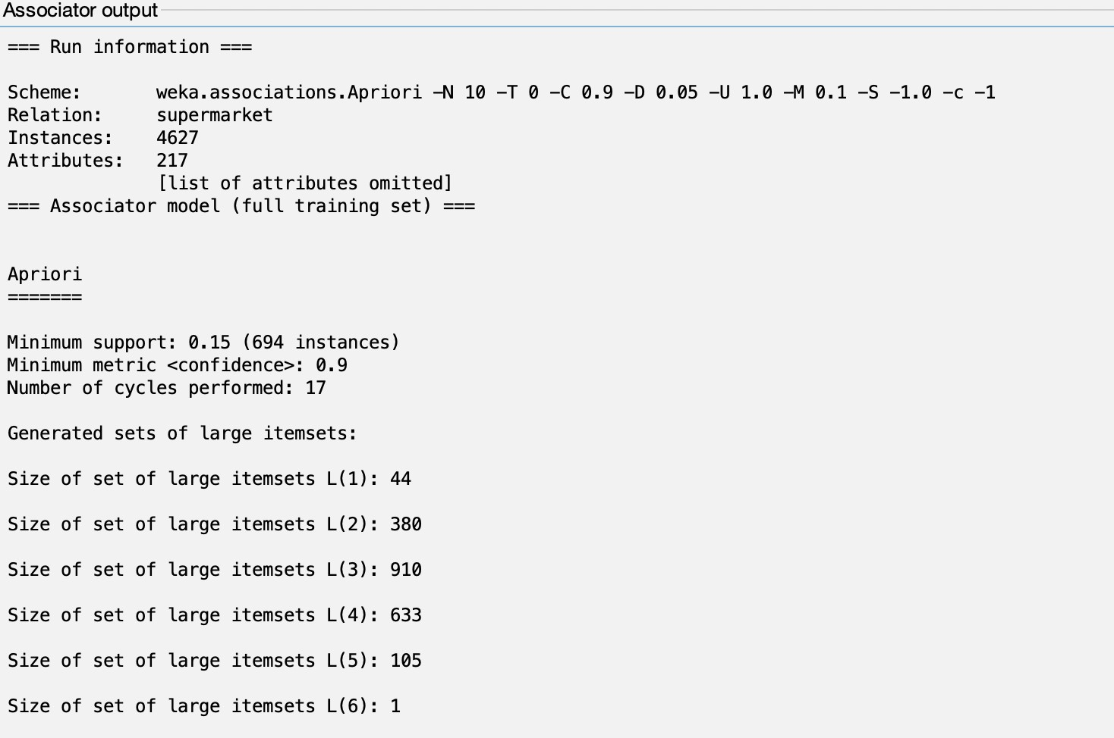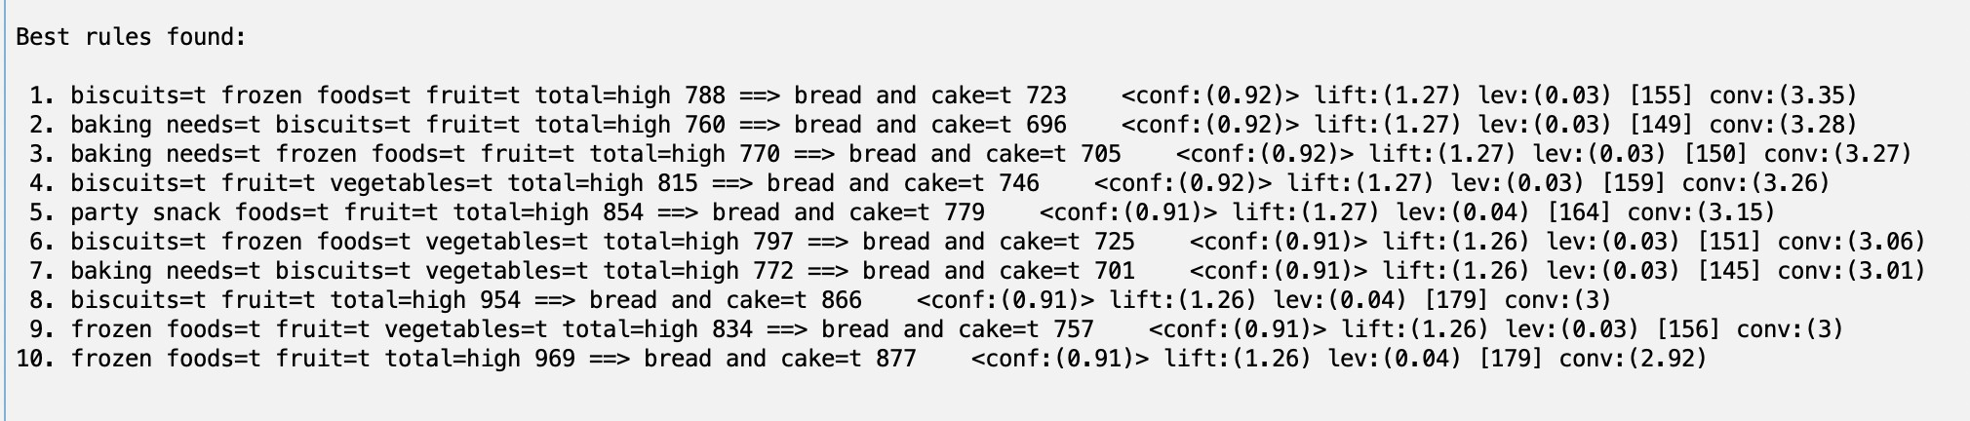

**Conclusion :**

We Implemented the apriori algorithm for association rule analyses on dataset .

**Practical – 9b**

**AIM OF EXPERIMENT :**

TO IMPLEMENT FP-Growth ALGORITHM

**DESCRIPTION :**

#### FP-Growth:

The FP-Growth Algorithm proposed by ***Han in***. This is an efficient and scalable method for mining the complete set of frequent patterns by pattern fragment growth, using an extended prefix-tree structure for storing compressed and crucial information about frequent patterns named frequent-pattern tree (FP-tree).

The FP-Growth Algorithm is an alternative way to find frequent item sets without using candidate generations, thus improving performance. For so much, it uses a divide-and- conquer strategy. The core of this method is the usage of a special data structure named frequent-pattern tree (FP-tree), which retains the item set association information.

#### Python Implementation:

Dataset Load

dataset = [['Milk', 'Onion', 'Nutmeg', 'Kidney Beans', 'Eggs', 'Yogurt'],

['Dill', 'Onion', 'Nutmeg', 'Kidney Beans', 'Eggs', 'Yogurt'], ['Milk', 'Apple', 'Kidney Beans', 'Eggs'],

['Milk', 'Unicorn', 'Corn', 'Kidney Beans', 'Yogurt'],

['Corn', 'Onion', 'Onion', 'Kidney Beans', 'Ice cream', 'Eggs']]

Load require packages

import pandas as pd

from mlxtend.preprocessing import TransactionEncoder

Transform the data

te = TransactionEncoder()

te_try = te.fit(dataset).transform(dataset)

Generate Dataframe

df = pd.DataFrame(te_try, columns=te.columns_) df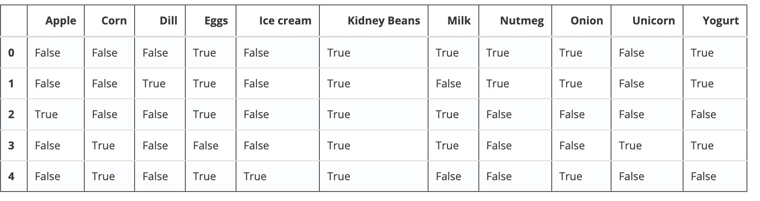

Model Training

from mlxtend.frequent_patterns import fpgrowth fpgrowth(df,min_support=0.5)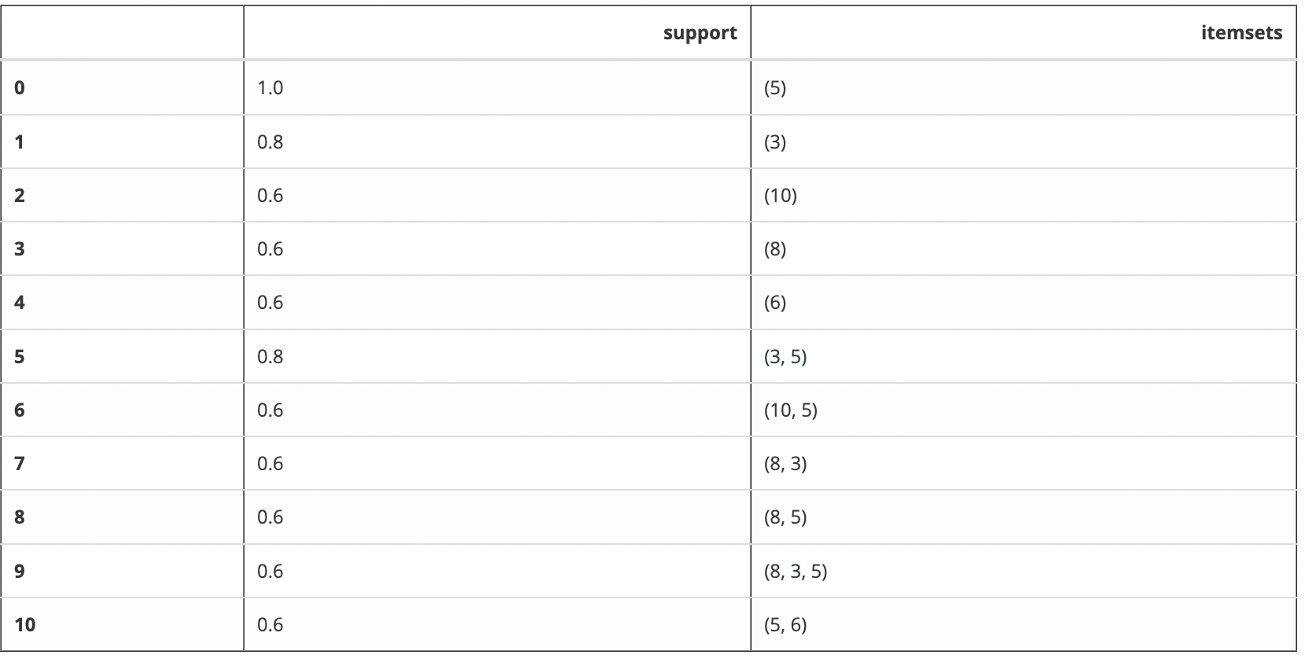

Model Training with Column Result return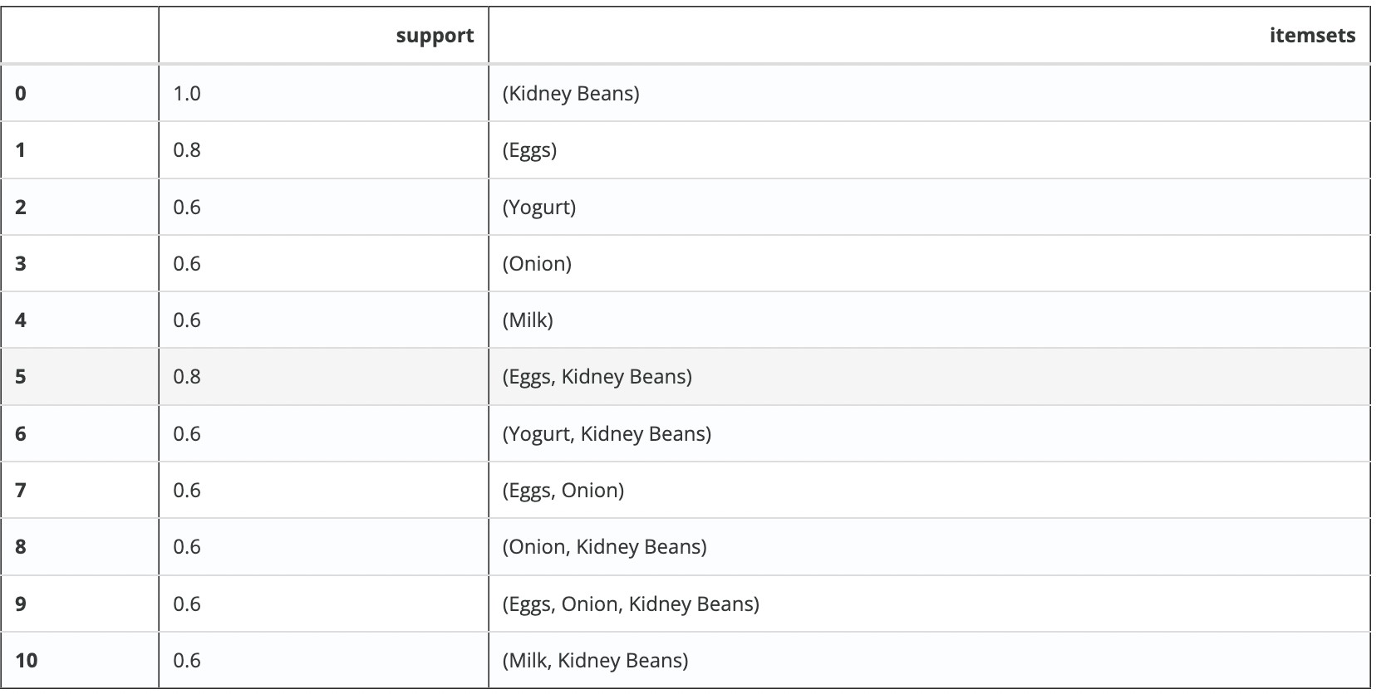

apriori(df,min_support=0.5, use_colnames=True)

#### Weka Implementation of FP Growth:

1. Load the Supermarket Dataset into Explorer.
2. Open the association tab.
3. Choose FP Growth algorithm for association
4. Click on start.

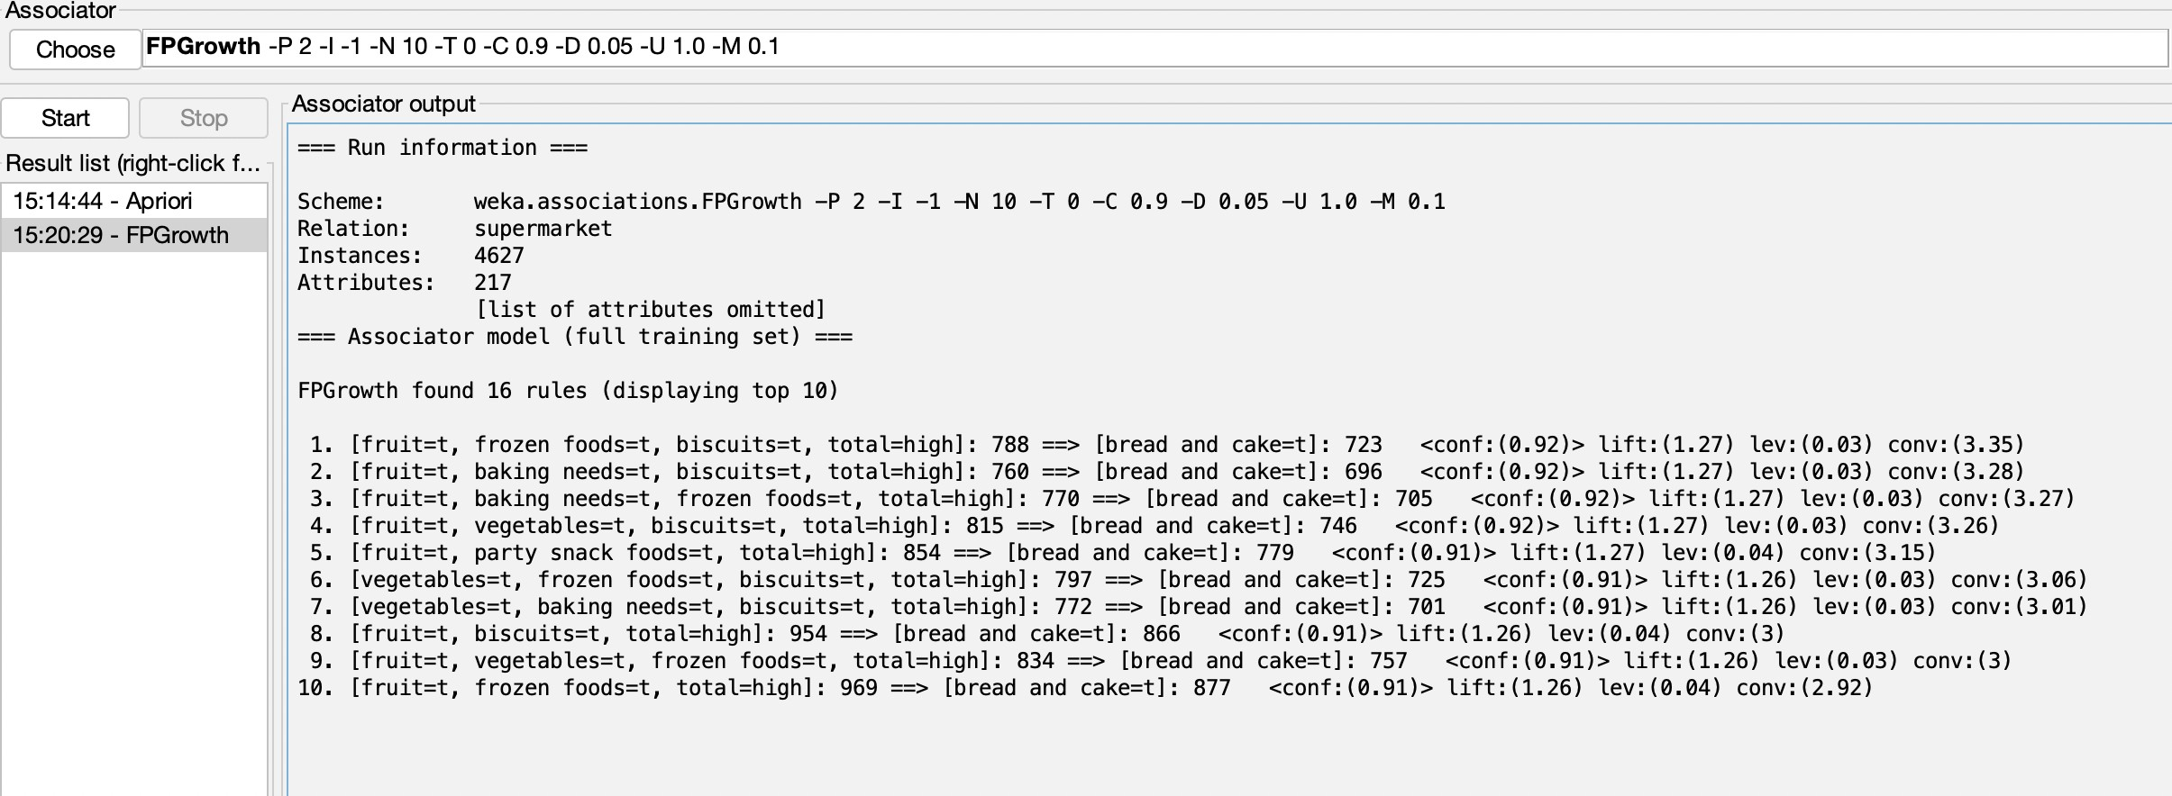

**Conclusion:**

We Implemented the FP Growth algorithm for association rule analyses on dataset In Python and Weka.

**Practical-10(a)**

**AIM OF EXPERIMENT:**

To Implement K-Means Clustering Algorithm.

**Description:**

K-Means Clustering is an Unsupervised Learning algorithm, which groups the unlabelled dataset into different clusters.

*“It is an iterative algorithm that divides the unlabelled dataset into k different clusters in such a way that each dataset belongs only one group that has similar properties.”*

It allows us to cluster the data into different groups and a convenient way to discover the categories of groups in the unlabelled dataset on its own without the need for any training.

It is a centroid-based algorithm, where each cluster is associated with a centroid. The main aim of this algorithm is to minimize the sum of distances between the data point and their corresponding clusters.

The k-means clustering algorithm mainly performs two tasks:

* Determines the best value for K centre points or centroids by an iterative process.
* Assigns each data point to its closest k-centre. Those data points which are near to the particular k-centre, create a cluster.

Hence each cluster has datapoints with some commonalities, and it is away from other clusters. The working of the K-Means algorithm is explained in the below steps:

**Step-1:** Select the number K to decide the number of clusters.

**Step-2:** Select random K points or centroids. (It can be other from the input dataset).

**Step-3:** Assign each data point to their closest centroid, which will form the predefined K clusters.

**Step-4:** Calculate the variance and place a new centroid of each cluster.

**Step-5:** Repeat the third steps, which means reassign each datapoint to the new closest centroid of each cluster.

**Step-6:** If any reassignment occurs, then go to step-4 else go to FINISH.

**Step-7**: The model is ready.

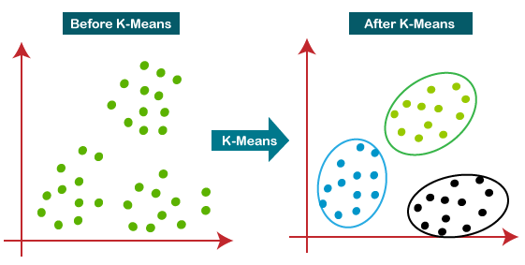

## Python Implementation:

**import** pandas **as** pd

**import** numpy **as** np

**from** sklearn **import** datasets

**from** sklearn.cluster **import** KMeans **import** matplotlib.pyplot **as** plt **import** matplotlib.patches **as** mpatches **import** sklearn.metrics **as** sm

%matplotlib inline

iris = datasets.load_iris()

x = pd.DataFrame(iris.data, columns=['Sepal Length', 'Sepal Width', 'Petal Length', 'Petal Width'])

y = pd.DataFrame(iris.target, columns=['Target']) x.head()

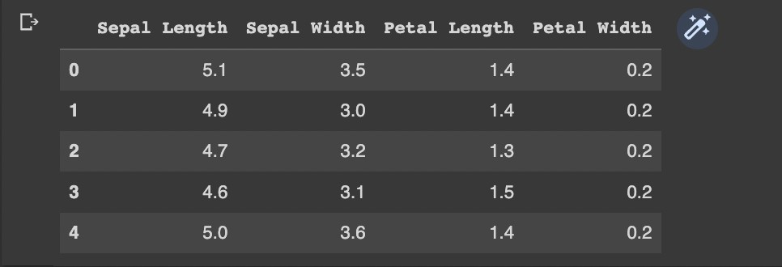

y.head()

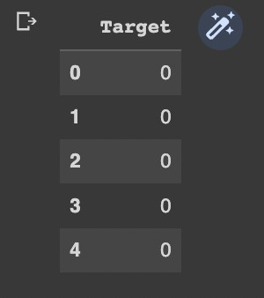

plt.figure(figsize=(12,3))

colors = np.array(['red', 'green', 'blue']) iris_targets_legend = np.array(iris.target_names) red_patch = mpatches.Patch(color='red', label='Setosa')

green_patch = mpatches.Patch(color='green', label='Versicolor') blue_patch = mpatches.Patch(color='blue', label='Virginica')

plt.subplot(1, 2, 1)

plt.scatter(x['Sepal Length'], x['Sepal Width'], c=colors[y['Target']]) plt.title('Sepal Length vs Sepal Width') plt.legend(handles=[red_patch, green_patch, blue_patch])

plt.subplot(1,2,2)

plt.scatter(x['Petal Length'], x['Petal Width'], c= colors[y['Target']]) plt.title('Petal Length vs Petal Width')

plt.legend(handles=[red_patch, green_patch, blue_patch])

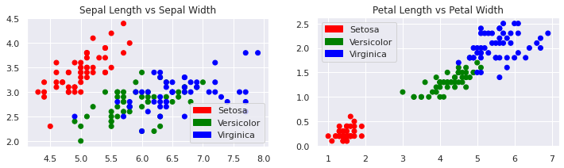

iris_k_mean_model = KMeans(n_clusters=3) iris_k_mean_model.fit(x)



**print** (iris_k_mean_model.labels_)

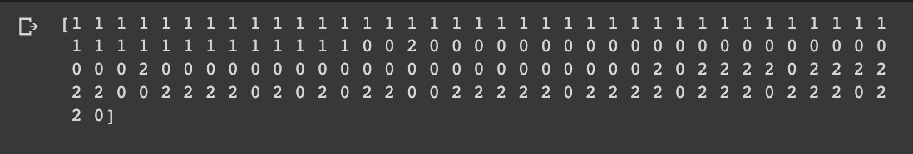

**print** (iris_k_mean_model.cluster_centers_)

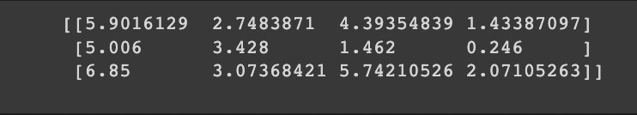

plt.figure(figsize=(12,3))

colors = np.array(['red', 'green', 'blue'])

predictedY = np.choose(iris_k_mean_model.labels_, [1, 0, 2]).astype(np.int64)

plt.subplot(1, 2, 1)

plt.scatter(x['Petal Length'], x['Petal Width'], c=colors[y['Target']]) plt.title('Before classification')

plt.legend(handles=[red_patch, green_patch, blue_patch])

plt.subplot(1, 2, 2)

plt.scatter(x['Petal Length'], x['Petal Width'], c=colors[predictedY]) plt.title("Model's classification")

plt.legend(handles=[red_patch, green_patch, blue_patch])

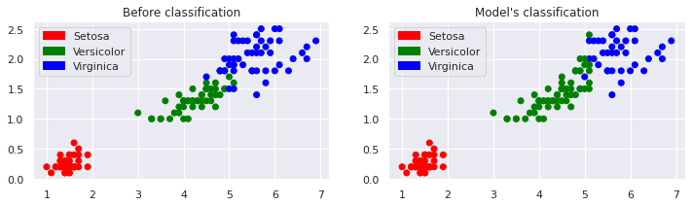

sm.accuracy_score(predictedY, y['Target'])



sm.confusion_matrix(predictedY, y['Target'])

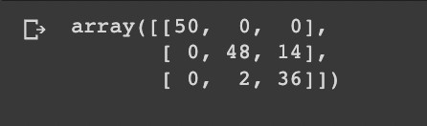

## Weka Implementation of K-Means Clustering

1. Open Weka Application
2. Open the Explorer Window.
3. Click the Open file button and select Iris Dataset.
4. Click on Edit to View the dataset

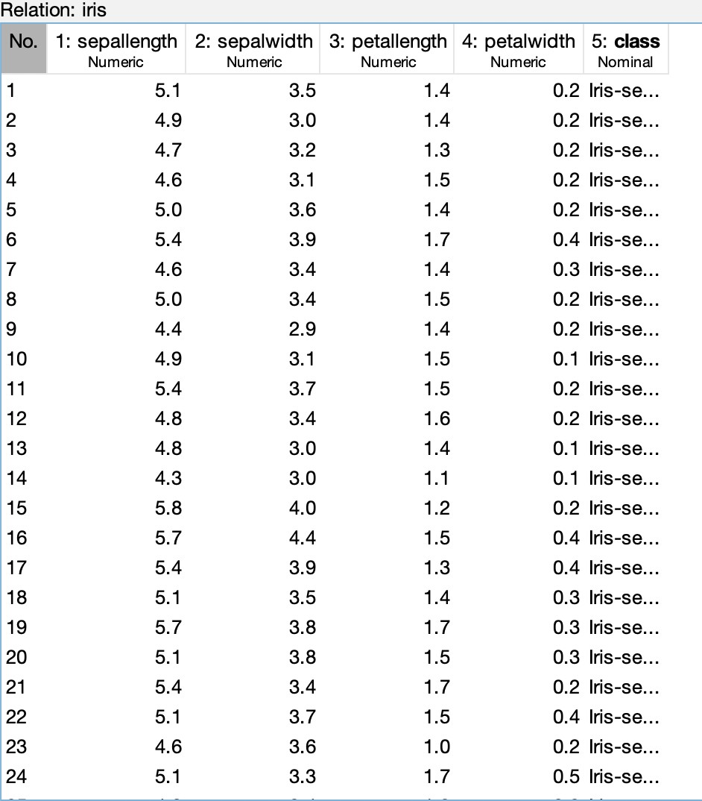

1. Now Click on the Cluster Tab on the top bar.
2. Click the choose button.
3. Select the SimpleKmeans Clustering.

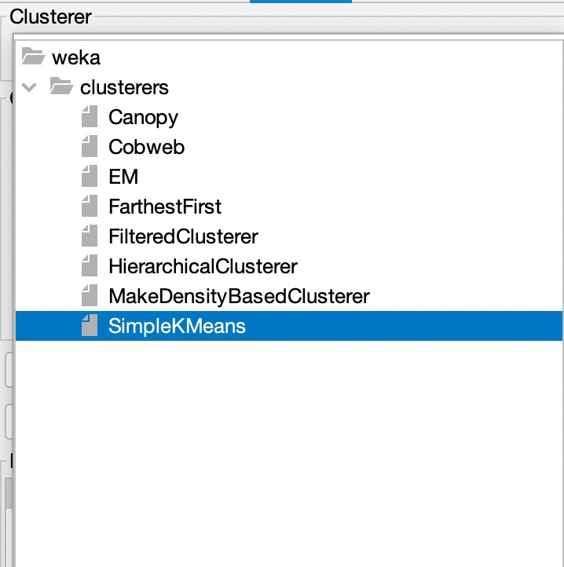 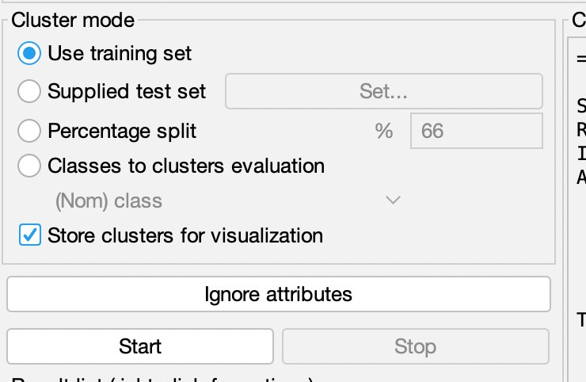

1. Select the Use training set Test Option.
2. Check Box to store for visualization. Click on Start.

**Result :**

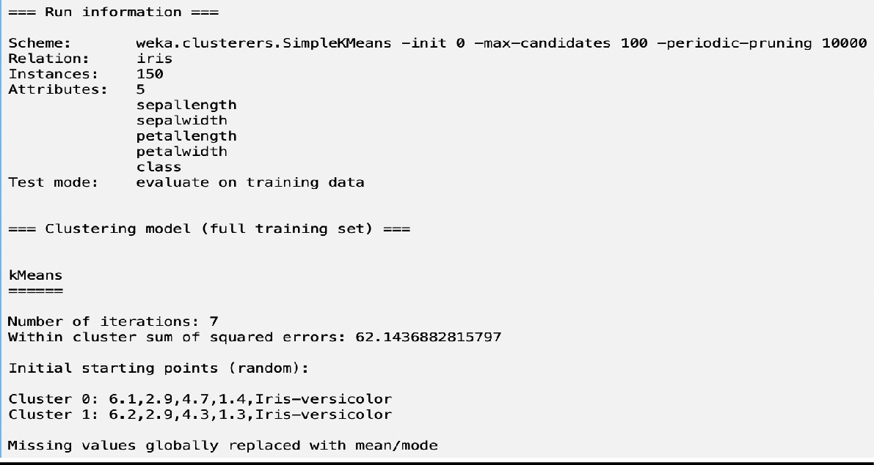

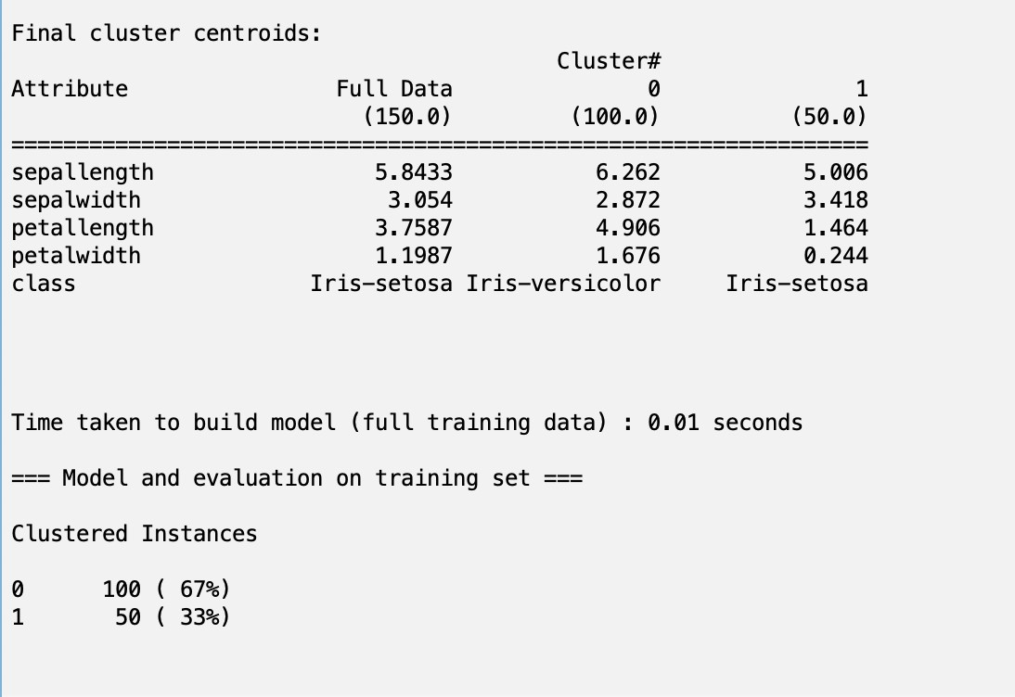

**Conclusion:**

We Implemented the K-Means Clustering Algorithm using python and also using Weka.

# **Practical – 10b**

## Aim of Experiment:

Calculating Information Gain Measure.

## Description:

Information gain can be defined as the amount of information gained about a random variable or signal from observing another random variable. It can be considered as the difference between the entropy of parent node and weighted average entropy of child nodes.

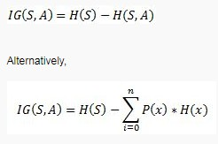

In machine learning, **entropy** is a measure of the randomness in the information being processed. The higher the entropy, the harder it is to draw any conclusions from that information.

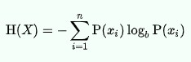

Information gain (IG) measures how much “information” a feature gives us about the class. – Features that perfectly partition should give maximal information. – Unrelated features should give no information. It measures the reduction in entropy. CfsSubsetEval aims to identify a subset of attributes that are highly correlated with the target while not being strongly correlated with one another. It searches through the space of possible attribute subsets for the “best” one using the BestFirst search method by default, although other methods can be chosen. To use the wrapper method rather than a filter method, such as CfsSubsetEval, first select WrapperSubsetEval and then configure it by choosing a learning algorithm to apply and setting the number of crossvalidation folds to use when evaluating it on each attribute subset.

## Python Implementation:

**import** pandas **as** pd

**import** numpy **as** np

**import** matplotlib.pyplot **as** plt

play_data = pd.read_csv('https://raw.githubusercontent.com/edyoda/data-science- complete-tutorial/master/Data/tennis.csv.txt')

play_data

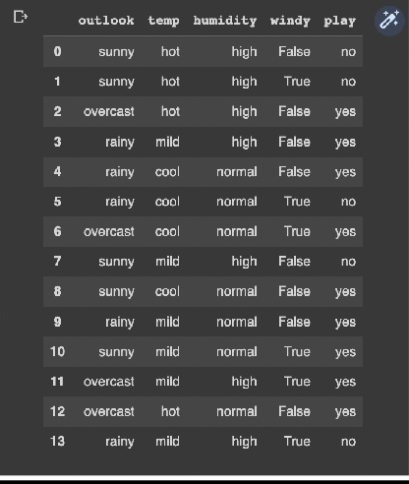

play_data.play.value_counts()

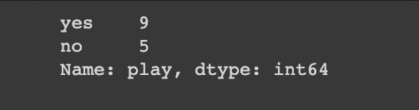

Entropy_Play = -(9/14)*np.log2(9/14) -(5/14)*np.log2(5/14)

Entropy_Play



play_data[play_data.outlook == 'sunny']

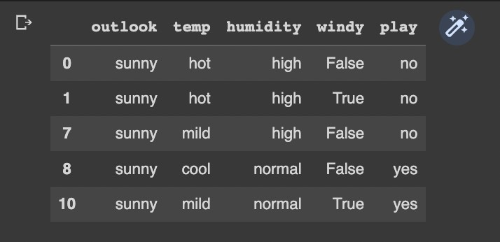

# Entropy(Play|Outlook=Sunny)

Entropy_Play_Outlook_Sunny =-(3/5)*np.log2(3/5) -(2/5)*np.log2(2/5)

Entropy_Play_Outlook_Sunny

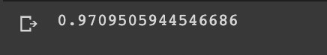

play_data[play_data.outlook == 'overcast'] # Entropy(Play|Outlook=overcast)

# Since, it's a homogenous data entropy will be 0

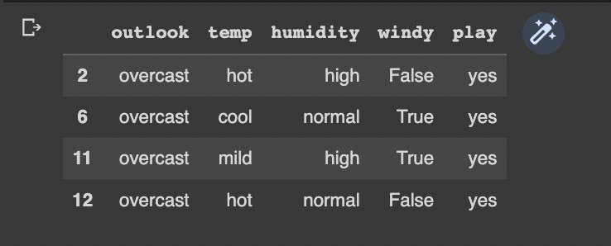

play_data[play_data.outlook == 'rainy']

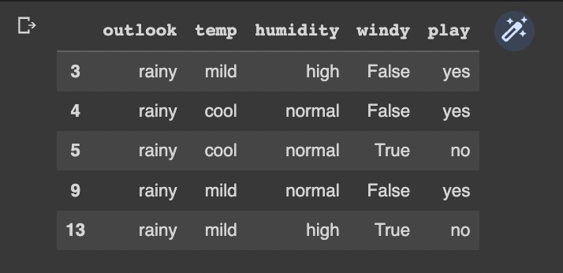

# Entropy(Play|Outlook=rainy)

Entropy_Play_Outlook_Rain = -(2/5)*np.log2(2/5) - (3/5)*np.log2(3/5)

Entropy_Play_Outlook_Rain



"""Gain on splitting by attribute outlook"""

Entropy_Play - (5/14)*Entropy_Play_Outlook_Sunny - (4/14)*0 - (5/14) * Entropy_Play_Outlook_Rain



"""Other gains

Gain(Play, Temperature) - 0.029 Gain(Play, Humidity) - 0.151 Gain(Play, Wind) - 0.048

Conclusion - Outlook is winner & thus becomes root of the tree

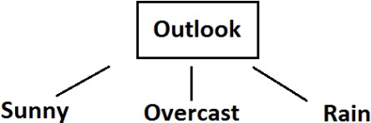

Time to find the next splitting criteria """

play_data[play_data.outlook == 'overcast']

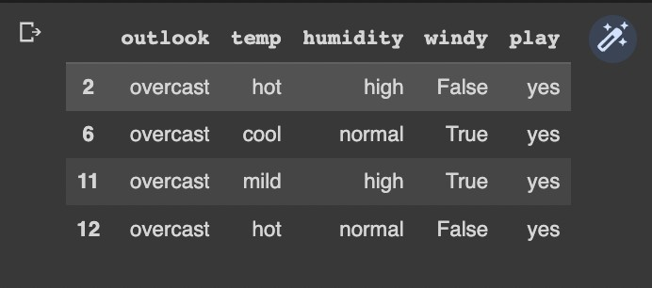

"""Conclusion - If outlook is overcast, play is true Let's find the next splitting feature

"""

play_data[play_data.outlook == 'sunny']

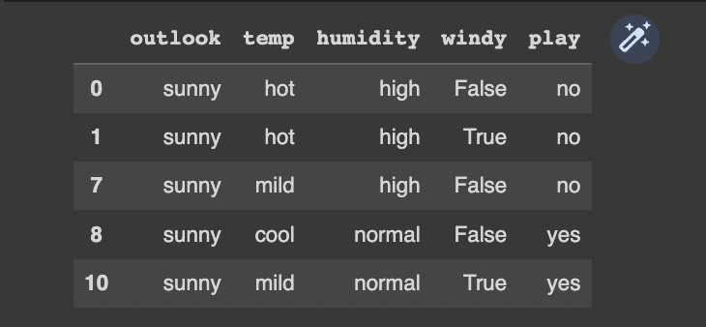

# Entropy(Play_Sunny|)

Entropy_Play_Outlook_Sunny =-(3/5)*np.log2(3/5) -(2/5)*np.log2(2/5)

Entropy_Play_Outlook_Sunny



"""Information Gain for humidity"""

#Entropy for attribute high = 0, also entropy for attribute normal = 0 Entropy_Play_Outlook_Sunny - (3/5)*0 - (2/5)*0



"""Information Gain for windy False -> 3 -> [1+ 2-]

True -> 2 -> [1+ 1-] """

Entropy_Wind_False = -(1/3)*np.log2(1/3) - (2/3)*np.log2(2/3) Entropy_Wind_False

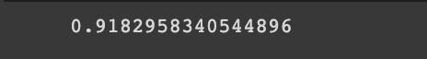

Entropy_Play_Outlook_Sunny - (3/5)* Entropy_Wind_False - (2/5)*1

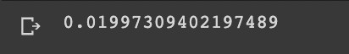

"""Information Gain for temperature' hot -> 2 -> [2- 0+]

mild -> 2 -> [1+ 1-]

cool -> 1 -> [1+ 0-] """

Entropy_Play_Outlook_Sunny - (2/5)*0 - (1/5)*0 - (2/5)* 1



"""Conclusion : Humidity is the best choice on sunny branch

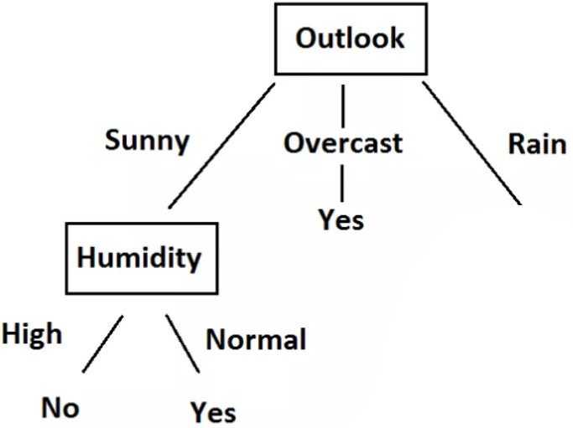

## Weka Implementation :

1. Open Weka Application
2. Open the Explorer Window
3. Click on Open File button.
4. Choose the Weather.arff file or any other dataset.
5. Click on edit to see the dataset table

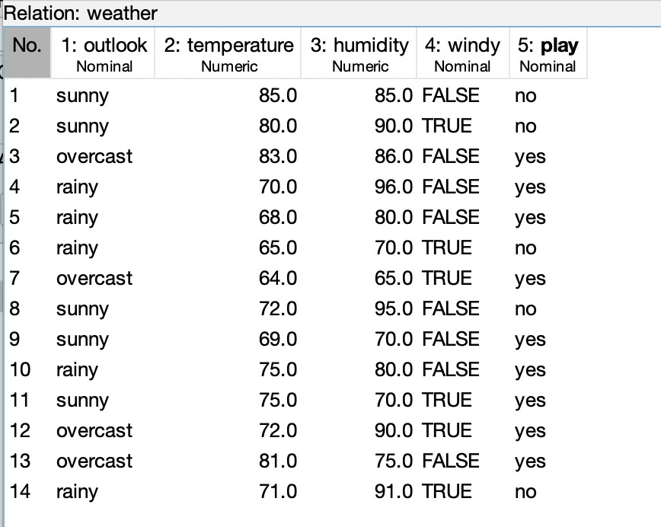

1. Click on the select attribute tab to open it.
2. Choose under attribute evaluator InfoGainAttributeEval
3. Under search method choose Ranker method
4. Select full training set under attribute selection mode.
5. Click on start.

**Result:**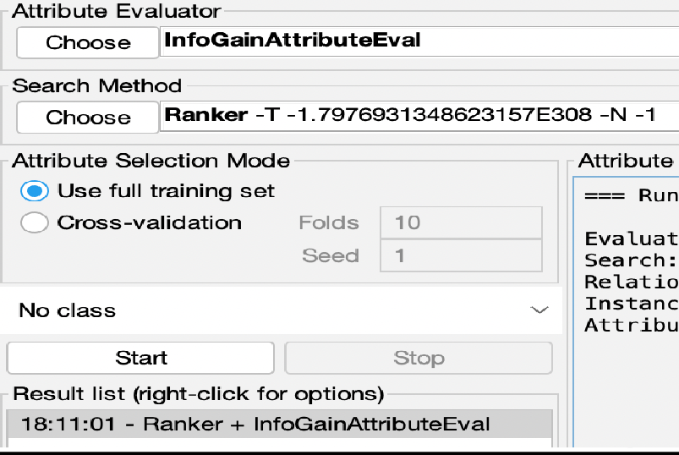

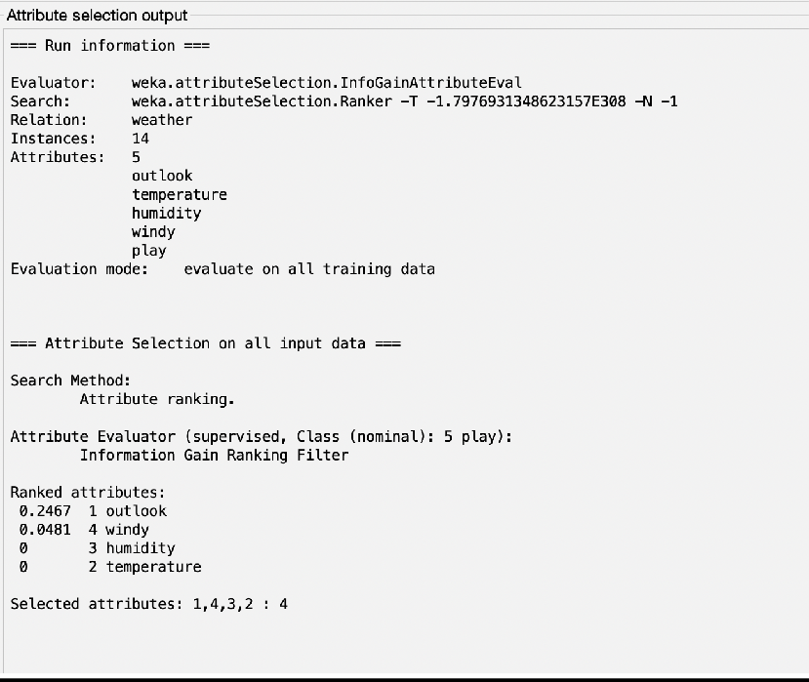

**Conclusion:**

We implemented Attribute Selection Using Information Gain using python and Weka.